MOPAC VAWG Grassroots Fund

Prospectus

November 2020

**ocument**

MOPAC VAWG Grassroots Fund

Prospectus

March 2020



londoncf.org.uk

Contents

1. Foreword 4

1.1 The Deputy Mayor for Policing and Crime’s foreword 4

2. About the Fund 7

2.1. Overview 8

2.2 About grassroots 12

2.3 By and for approach 13

2.4 Funding available 14

2.5 Key features of the Fund 15

2.6 Key dates 15

3. Criteria 17

3.1 Objectives 17

3.2 The Mayor’s VAWG strategy 18

3.3 Fund priorities 19

3.4 Geography 21

3.5 Funding split 22

4. Eligibility 23

4.1 Who can apply? 23

4.2 Grant size 25

4.3 Partnerships 25

4.4 Eligible costs 27

4.5 Living Wage Funder 28

5. Benefits of the programme 29

5.1 Capacity building 30

5.2 Networking and peer support 31

6. How to apply 32

6.1 Initial eligibility checker and application form 32

6.2 Application guidance 33

6.3 Applicant support and FAQs 35

7. Assessment and decision making 36

7.1 What happens after the Fund deadline? 36

7.2 Assessment framework 38

7.3 What happens after grants are awarded 39

8. Monitoring and reporting on your grant 40

8.1 Reporting schedule 41

8.2 What to do if things are going well, or not so well 42

8.3 Data management 43

9. Fund evaluation 44

9.1 Engaging in evaluation 44

9.2 Engaging service users in evaluation 44

9.3 Potential for engagement with MOPAC Evidence & Insights Team 44

46

10. Thank you 46

11. Contact details 47

12. Comments and complaints 48

Appendix A: Glossary 49

Appendix B: VAWG statistics 52

Appendix C: funding split examples 55

Appendix D: grant size examples 58

Appendix E: Theory of Change 59

Appendix F: What we heard from you 62

Appendix G: Eligibility and due diligence 65

Appendix H: Shortlisting framework 66

Appendix I: Victim’s Fund 2020/21 67

Appendix J: About us 68

About MOPAC 68

About The Social Innovation Partnership 68

About The London Community Foundation 69

1. Foreword

1.1 The Deputy Mayor for Policing and Crime’s foreword

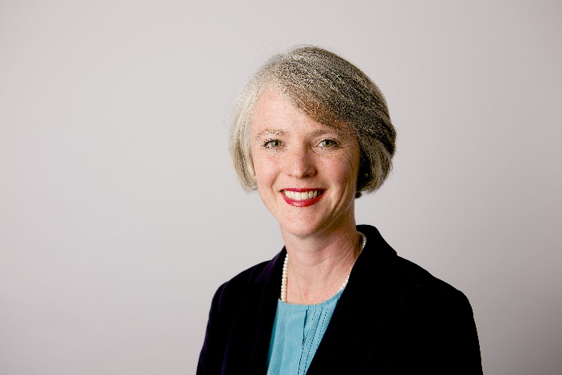

*Sophie Linden, Deputy Mayor for Policing and Crime*

Tackling violence against women and girls (VAWG) is one of the Mayor’s key priorities for policing and safety in London, set out in his Police and Crime Plan and in his VAWG Strategy. MOPAC and the wider GLA are delivering those strategies, working to prevent VAWG, to tackle perpetrators and to support victims of these crimes.

However, this work has been hampered by the pressures arising from years of deep Government funding cuts, increasing demand and increasing operating costs. VAWG organisations – which need stability to continue their vital work of supporting victims and survivors – have been driven to breaking point, with smaller specialist grassroots organisations bearing the brunt.

Recognising and responding to this urgent need, the Mayor announced the creation of a new VAWG Fund, providing £15m in additional funding for services for victims and survivors of VAWG. Over £10m of this has already been deployed to organisations who are achieving great outcomes for women and girls across London.

The Covid-19 outbreak and the lockdown measures needed to tackle it have heightened vulnerabilities and added further pressure onto the sector. The Mayor has invested a further £1.5m in emergency funding to provide more refuge places for victims and survivors fleeing domestic abuse during lockdown.

£3m has been set aside from the Mayor’s VAWG Fund to focus on supporting existing specialist grassroots organisations operating across London’s diverse communities to end VAWG. Grassroots organisations are often the first and sometimes the only support contact for many survivors of VAWG, in particular women and girls and from marginalised groups.

Grassroots organisations often face considerable challenges in accessing funding with many BME organisations disproportionately affected by this.

Following an open tender process, The London Community Foundation (LCF) have been appointed as the Fund Manager for Developing Grassroots Provision in the Violence Against Women and Girls (VAWG) sector. I am pleased to introduce this Prospectus, which sets out how grassroots VAWG organisations can access funding to maintain their service provision in continuing to meet the needs of different communities and individuals and also receive vital support to strengthen sustain their organisations.

From sources including the Crime Survey for England and Wales (CSEW) we know that domestic abuse and sexual offences are disproportionately experienced by women; 76% and 87% respectively. As a reflection of the disproportionate impact of these crimes on this group, our primary focus for this fund is on services that support to women and girls.

This does not mean that we diminish or ignore the suffering experienced by men and boys and many of existing MOPAC funded services support them.

Grassroots VAWG organisations play such an important role in London, and will continue to do so as we begin the process of recovery from the Covid-19 outbreak. I warmly welcome your engagement with this new fund, and I look forward to seeing the difference we can make together for vulnerable women and girls in our city.

Thank you for the work you continue to do for victims and survivors of VAWG in London.

**Sophie Linden**

**Deputy Mayor for Policing and Crime**

1. About the Fund

The Covid-19 pandemic has had a damaging impact on community organisations and has changed the way we work for the foreseeable future. We are now operating in a context where violence against women and girls (VAWG) is occurring alongside a global health crisis and are aware that this has further facilitated opportunities for violence and abuse.

We recognise that Black and Minority Ethnic (BME) communities are disproportionately affected by Covid-19 and that existing structural inequalities have contributed to this outcome. We also recognise that grassroots organisations serving BME communities continue to deliver vital support to the worst affected communities in London. We appreciate that now - more than ever - ring-fenced funding for BME VAWG organisations is needed.

Applications to the [London Community Response Fund](https://londoncommunityresponsefund.org.uk/) (LCRF) demonstrate that grassroots organisations, including VAWG-specific organisations, have rapidly adapted their services to meet a growing demand in need and to meet Government guidelines. Many organisations have used reserves to achieve this, leaving them in vulnerable financial positions. VAWG organisations are already responding innovatively to reach vulnerable and disadvantaged women and girls in London, using appropriate service design and community engagement methods.

**In May 2020 survey responses from 54 VAWG community organisations and a Fund Co-design event told us that the Covid-19 outbreak had led to:**

* an increase in the complexity of cases
* an increase in demand for specialist VAWG services
* a need for grassroots service expansion to meet emerging needs
* a reinforcement of the need for funding programmes, wider than this fund alone, which contribute to core costs
* concerns about the survival of grassroots organisations

We are committed to ensuring these needs are supported by the VAWG Grassroots Fund Programme and ensure that this Fund is accessible, flexible and transparent to be able to support and sustain VAWG grassroots organisations.

2.1. Overview

The London Community Foundation is pleased to launch the Mayor’s Violence Against Women and Girls (VAWG) Grassroots Fund. This Fund is managed in partnership with The Social Innovation Partnership (TSIP). This £3m Fund will help support existing VAWG-specialist grassroots organisations operating across London’s diverse communities so they can better meet the needs of their users experiencing VAWG.

The VAWG Grassroots Fund is delivered in alignment with the [MOPAC Victim’s Fund](https://londoncf.org.uk/grants/mopac-victims-fund). We are available to provide support to applicants to decide which Fund is more appropriate. Further information on the Victim’s Fund is outlined in Appendix I.

The Mayor’s Office for Policing and Crime’s (MOPAC) [VAWG evidence pack](https://www.london.gov.uk/sites/default/files/annex_1_-_evidence_pack.pdf) shows how the climate of austerity including cuts in legal aid, housing and welfare benefits has seriously reduced services and consequently the support available to help survivors escape violence and abuse. Meanwhile, demand for specialist support has grown both in volume and complexity of need. Furthermore, small charitable organisations that help specific communities experiencing VAWG have struggled to keep services going, amidst reduced or short-term project funding. This has been exacerbated by the Covid-19 pandemic.

These grassroots charitable organisations also face barriers to different funding sources and how they are promoted, according to MOPAC’s [VAWG evidence pack](https://www.london.gov.uk/sites/default/files/annex_1_-_evidence_pack.pdf). This means women and girls experiencing VAWG in London do not have equal access to the support they need. Women and girls experience disproportionate harm from certain types of crime (see Appendix B: VAWG statistics). Women and girls of particular demographics then face multiple exclusions from mainstream services, whilst grassroots BME specific services have been disproportionately affected by funding challenges.

Imkaan, the only UK-based, second-tier women's organisation dedicated to addressing violence against black and minoritised women and girls. Feedback from their members ([From Survival to Sustainability, 2018](https://829ef90d-0745-49b2-b404-cbea85f15fda.filesusr.com/ugd/2f475d_9cab044d7d25404d85da289b70978237.pdf)) suggests that commissioning processes are failing BME focused VAWG organisations in that they:

1. Privilege larger, more well-resourced providers through, e.g. short bidding timelines, complex tenders, exclusion criteria such as large turnovers;
2. Do not adequately embed equalities e.g. structured to favour bidders who can provide support at lower costs and have a larger reach in terms of numbers;
3. Do not allow for meaningful intersectional work across diverse identities and/or strands of VAWG e.g. many BME providers work across the VAWG spectrum addressing issues such as domestic violence, child sexual exploitation, forced marriage and so-called ‘honour’ based violence as a routine part of their case-work; and
4. Fail to recognise the added value that BME providers bring which carries no weight in tender processes, with funders ignoring the ‘added value’ and/or social value that these providers can bring.

The VAWG Grassroots Fund has been developed to respond to these issues and provide targeted support for these organisations and redress the imbalance of funding to the grassroots sector.

In light of the Covid-19 pandemic and evidence about communities disproportionately affected by the outbreak, we recognise that despite funding imbalances, specialist grassroots organisations have been at the forefront of emergency response work.

By- and for- services continue to provide invaluable support to London’s diverse communities. Through our involvement in the London Community Response Fund, we have learned that to respond to emerging needs, grassroots organisations have expanded their services and are engaging in more holistic service delivery, which includes addressing food insecurity, providing employment support and helping women find suitable emergency accommodation.

The Fund will support the development of a more resilient grassroots response to VAWG in the capital through a programme of funding for VAWG service delivery, accompanied with support for a co-designed capacity building programme, peer support and networking.

The VAWG Grassroots Fund will support and promote the voice of VAWG-specialist organisations working deep in London’s communities to bring support and hope to women and girls affected by violence.

The unique and trusted role grassroots organisations have in tackling VAWG with their communities will be recognised and valued through how decisions are be made about funding and the type of support the grantees receive.

Thank you to all the VAWG-specialist grassroots organisations who helped to co-produce this Prospectus and priorities for the Fund. This Fund is one important element of the Mayor’s [Strategy to end VAWG](https://www.london.gov.uk/mopac-publications/mayors-violence-against-women-and-girls-strategy-2018-2021).

We recognise that the Violence against Women and Girls (VAWG) sector is a large and varied space. We have chosen particular terminology based on our consultation and experience with grassroots organisations. LCF does not want to exclude those who use other languages and we recognise many of these terms are interchangeable. Please see the glossary in Appendix A for a definition of all terms and abbreviations used in this Prospectus.



*The Maya Centre, Images about their mental health created by clients affected by VAWG*

2.2 About grassroots

LCF defines grassroots organisations as rooted in, and led by, the communities that they serve. In this context we mean communities of women and girls who may or may not live in the same local area but who are connected by their social identity and shared concerns, e.g. a community of disabled women or a network of BME survivors of sexual violence.

**In line with this definition, we include grassroots organisations as:**

* Specialist BME organisations addressing VAWG
* Women’s community organisations delivering services to address VAWG as a core aspect of their work; and, or
* Specialist community organisations (e.g. disability rights groups providing services that address VAWG as a core aspect of their work or groups providing support for women involved in prostitution)

Grassroots organisations are often the first (and sometimes the only) support contact for many survivors of VAWG, particularly those from BME communities and women and girls who face multiple disadvantage.

The Mayor is launching this Fund to help address the needs of women facing multiple disadvantage; the needs of minoritised women from BME backgrounds; LBTQ+ women, disabled women, women with NRPF and women involved in prostitution where mainstream, generic provision is not always appropriate.

2.3 By and for approach

In a [MOPAC commissioned consultation](https://www.london.gov.uk/sites/default/files/mopac_survivors_consultation.pdf), survivors told of the importance of being able to access support from BME-led *by* and *for* ending-VAWG organisations that understood the myriad of issues they faced. This was not simply about the community, family or religious contexts. Women spoke of feeling safer and more trusting of BME-led women’s organisations with, for example, information about their immigration context and/or sharing their individual experiences of racism. This Fund has been created to invest in grassroots BME-led *by-* and *for-* organisations, so women continue to have spaces where they feel safe, heard and understood.

Women and girls experience violence within a broader context of structural inequality. Women’s needs often have direct link to the discrimination they face on the basis of individual or multiple protected characteristics e.g. sex/gender, sexual orientation, race/ethnicity, disability, age and religion. This is true of LBTQ+, disabled women, those experiencing FGM, so-called ‘honour’ based violence or those with insecure immigration status – as well as many others.

By- and for- services can respond to the complex, intersecting needs of survivors. This means women can disclose in the knowledge that they are understood and believed when able to access services that understand the context in which the abuse happens and the cultural nuances that can be part of the abusive pattern.

When survivors of VAWG seek support, they can also encounter barriers and exclusions, which are linked to factors such as race. This can have a direct impact on all aspects of their lives including their safety. That’s why this Fund wants to support grassroots organisations which recognise that many women and girls experience a clear relationship between these factors and how they seek, access and engage with services.

For example, provision which is designed, developed and delivered by disabled women for disabled women centres on the needs of disabled women rather than viewing those needs as an add on. In practice this means that for many minoritised women and girls, *by-* and *for-*, grassroots organisations offer the most appropriate and effective support systems. That’s why VAWG-specialist grassroots organisations that can demonstrate a by- and for- approach are the focus for this new Fund and support programme.

2.4 Funding available

The Fund will provide two-year grants of up to £100,000 (£50,000 per year) for individual organisations.

Partnerships of up to three organisations can apply for two-year grants of up to £120,000 (£60,000 per year). In order to qualify as a partnership, applicants must have a partnership agreement (written document) or equivalent in place before applying.

We expect between 40-50 grants to be awarded from the £3m available funds.

2.5 Key features of the Fund

* Two-year grant funding to specialist, grassroots ending VAWG organisations. There is no income threshold for the Fund however organisations with an annual income of less than £500,000 will be prioritised.
* A minimum of 60% of funding will be prioritised for grassroots, specialist organisations for which:
  + Ending VAWG is their organisation’s priority
  + Provide services for BME women
  + Can demonstrate they are led by BME women
* A maximum of 40% will be for specialist grassroots community organisations who provide ending VAWG services for marginalised groups such as disabled women, LBTQ+ women, women with no recourse to public funds (NRPF) and women involved in prostitution
* Capacity-building support programme to be co-designed with grantees
* Networking events and peer support across grantees
* Engagement of grantees in evaluation

2.6 Key dates

The Fund opens for 8 weeks on Monday 16th November 2020. LCF is holding a range of online and telephone Applicant Support whilst the Fund is open. Click [here](https://londoncf.org.uk/grants/vawg-grassroots-fund) for details.

**The deadline for full applications is 12:00 (midday) on 11th January 2021.**

We need to receive all supporting documents by the deadline for your application before this deadline to be complete. We regret we are unable to consider incomplete applications.

The timeline for delivery is 1st April 2021 to 31st March 2023. Grants cannot be retrospective or cover activities taking place before this time. If requesting funding towards a new post or other elements which bring higher risks to project delivery, please consider additional time and contingencies in your planning.

1. Criteria

3.1 Objectives

**The objectives of the VAWG Grassroots Fund are to:**

* Support VAWG grassroots organisations to sustain their services, especially in light of the Covid-19 outbreak;
* Build the capacity of existing services for women and girls affected by VAWG;
* Sustain effective interventions that are facing challenges in continuing service delivery, including maintaining existing services, whilst supporting the stability of grassroots organisations;
* Increase the accessibility of grassroots organisations best placed to respond to the needs of London’s diverse communities and women with no recourse to public funds for whom mainstream, generic provision is not always appropriate or safely accessible;
* Fund services that are responsive to communities of protected demographic groups at a grassroots level and can reach survivors across borough boundaries. Particularly in areas where there are gaps in provision and a specialist service may not be commissioned locally due to low density of users;
* Sustained services for survivors to allow opportunity for recovery, allowing them the time to heal, be empowered, gain independence and address the multiple issues they may face;
* Survivors experience better outcomes as a result of the Fund validating and sharing best practice, e.g. of models, recognised safeguarding and clinical and recovery frameworks;
* Develop networks of experts in services tackling VAWG to build overall sector capacity;
* Support the Voluntary and Community Sector to undertake robust performance monitoring and evaluation methods to demonstrate what difference the funding has made and what works.

3.2 The Mayor’s VAWG strategy

Applicants should clearly link their proposal to the Mayor’s wider VAWG Strategy, [which you can read here](https://www.london.gov.uk/mopac-publications/mayors-violence-against-women-and-girls-strategy-2018-2021), and the Fund’s Theory of Change (Appendix E).

**The Strategy sets out the priorities including:**

* Encouraging more victims of domestic abuse and of sexual violence to come forward and reducing repeat victimisation;
* Reducing the rates of women and girls dropping out of cases of VAWG as they progress through the criminal justice process;
* Encouraging more victims of harmful practices such as FGM, so-called ‘honour’ based violence and forced marriage to come forward and report.

**The VAWG Grassroots Fund will support organisations working towards outcomes linked to this Strategy, including, but not limited to:**

* Sustained ability to support victims/survivors of VAWG to cope and recover and providing them a platform to comment on and inform service delivery. This could involve supporting clients to feel safer, improve health and wellbeing, feel empowered to self-advocate or access services, or feel more confident in reporting crime
* Sustained efficiency of the service (both back office and front-line) that results in tailored provision, meeting the needs of survivors as appropriate to their individual circumstances and providing additional support where required
* Managing the demand on VAWG support services such as through strengthening inward and onward referral pathways
* Empowering and retaining staff and volunteers
* Diversification of income streams to improve the resilience of organisations and sustainability of services to support survivors in the long term

3.3 Fund priorities

**The Fund will prioritise organisations which:**

* Have a **track record** of meeting the increased/diverse needs of service-users;
* Can demonstrate deep **understanding** of their community need and context;
* Are run **by and for** the communities they serve, where the client group is reflected in staffing, management and governance structures;
* Deliver services which are **co-designed** with survivors, and delivered *with* survivors, not to or for;
* Can demonstrate **challenges** identified in consultation (short-term funding, loss of funding diversity, increased volume or complexity of demand for services), including recognising the additional challenges brought by the Covid-19 pandemic and associated lockdown measures;
* Can demonstrate their **need** for organisational investment to drive increased services/accessibility/reach/caseload or continuity/inclusivity of engagement;
* Recognise that VAWG is preventable and affects women and girls disproportionately due to unequal power relations (**gender-informed**);
* Deliver interventions that connect VAWG to wider **intersectional** inequalities including ethnicity, class, gender identity, age, disability, sexuality, religion, belief and immigration status which impact on experiences of abuse and access to safety, support and justice;
* Demonstrate an understanding of and responsiveness to the impact of trauma, that emphasises physical, psychological and emotional safety for both providers and survivors, and that creates opportunities for survivors to rebuild a sense of control and empowerment (**trauma-informed**);
* Have a commitment to **collaboration** and developing partnerships.

3.4 Geography

Women and girls suffer violence regardless of boundaries; they live, study, work, socialise and travel across London and can experience violence at home, in educational institutions, workplaces and public spaces. Women and girls may also move across different localities as part of their survival and help-seeking strategies. Their movement can relate to immediate safety issues, such as fleeing a local area as a result of violence; as well as seeking/accessing support appropriate to their individual need.

That’s why service users and their needs should dictate how and where services are delivered, whether that’s in one borough, multiple boroughs or London-wide.

Organisations based outside of Greater London may be considered for funding, but only activity within London and for Londoners will be considered and a track record of delivering your services within London must be demonstrated.

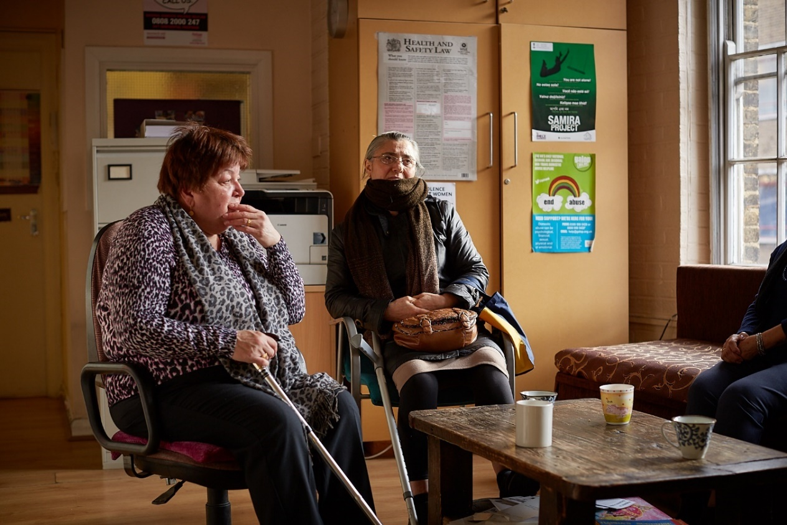

IMECE Women’s Centre

3.5 Funding split

VAWG grassroots organisations told us about their funding challenges, made more acute by the effects of the pandemic on income diversification activities, availability of funding programmes and fundraising. The funding available has been informed by existing and commissioned research referenced in section 2 ‘About the Fund’, and alongside consultation by sector experts. That’s why we are prioritising a minimum of 60% of this funding for grassroots organisations who are specialist BME women ending VAWG organisations and a maximum of 40% to grassroots organisations who are specialist community organisations who provide ending VAWG services for other marginalised groups such as disabled women, LBTQ+, women with NRPF and women involved in prostitution.

This priority means that if your organisation is not a BME by and for VAWG-specialist, there is likely to be higher competition for the available funds, i.e. 40% specialist grassroots organisations (as above). You should carefully consider this prior to making an application.

To help organisations thinking of applying to the Fund, we have provided some examples to illustrate the difference in Appendix C.

If you are in doubt as to whether your organisation is eligible based on this information, please contact [VAWGGrassrootsFund@londoncf.org.uk /](mailto:VAWGGrassrootsFund@londoncf.org.uk%20/) 020 3982 8803.

1. Eligibility

The Fund is focused on strengthening and supporting grassroots organisations providing services for survivors of VAWG in London, with an emphasis on provision of services by and for women from BME and marginalised communities. Projects that focus on harmful practices and support for women involved in prostitution are also eligible.

There is no income threshold for the Fund however organisations with an annual income of less than £500,000 will be prioritised.

4.1 Who can apply?

Only one application per organisation will be accepted. For further guidance on partnerships bids, see below.

**Applicants must:**

* Currently be providing services to address VAWG
* Be able to demonstrate a minimum of three complete years of operation
* Be delivering the work they are requesting funding for in London, with a preference for organisations based in London

**We will accept applications from organisations with the following legal status:**

* Constituted voluntary and community groups that have a minimum of 3 unrelated members responsible for the governance of the organisation; trustees / directors / management committee, as appropriate
* Registered charities
* Community Interest Companies (CIC) Limited by Guarantee
* Charitable Companies (Limited by Guarantee)
* Charitable Incorporated Organisations (CIO)

**We are unable to consider applications from, or that support, the following:**

* Local Authorities, or any activity that is a statutory requirement
* Any party-political activities
* Purely commercial ventures (for profit)
* Spending that has already taken place (i.e. retrospective funding)
* Community Interest Companies Limited by Shares
* Individual sponsorship / individuals or projects run by individuals as opposed to an organisation
* Activities promoting religious belief
* Statutory agencies in the criminal justice system, including the Metropolitan Police Service
* Organisations whose current liabilities have exceeded their current assets at the last two balance sheet dates
* Organisations where trustees are paid, unless evidence of approval is provided from the Charity Commission and/or this arrangement is referenced in the governing document
* Organisations with fewer than 3 unrelated members responsible for the governance of the organisation; trustees / directors / management committee, as appropriate

4.2 Grant size

For individual organisations, two-year grants of between £30,000 (£15,000 per year) and £100,000 (£50,000 per year) are available.

Partnerships of up to three organisations can apply for two-year grants of up to £120,000 (£60,000 per year) for the partnership.

If your organisation has an annual income of less than £30,000 you may need to demonstrate that you have the capacity, experience and/or contingency plans in place to manage the risk of dependency on one source of funding. Organisations with an annual income of less than £30,000 are encouraged to call the VAWG Fund Manager to discuss an appropriate size of grant request. For examples, please see Appendix C.

4.3 Partnerships

Established partnerships of up to three organisations can apply for two-year grants of up to £120,000 (£60,000 per year) for the partnership.

Lead partners (those organisations leading on a partnership bid) are subject to all the eligibility areas listed in section 4 of the prospectus.  Other Partners listed are subject to the eligibility criteria listed in section 4, with exception of the below which will be considered on a case by case basis.

* Lead partners must be able to demonstrate a minimum of three complete years of operation. However newer organisations (though still need to have been in operation since January 10th 2019 and be able to demonstrate this), for example those set up in response to a particular need, are able to be considered if they are applying under a partnership.  However, a track record of delivering VAWG services is still required.
* Intended financial distribution of the grant to partners should still be limited to up to 50% of their individual organisation’s annual turnover – but smaller organisations (with less than £30,000 annual income) are eligible to apply as a partner and have contributions of less than £15,000 a year if appropriate. The lead partner will be awarded the funds and then deploy the relevant amount to the sub-grantee
* If applying under a partnership bid, the lead partner must be confident with the sub-grantee organisation’s capacity to be able to deliver the proportion of the project which is assigned to a partner.  Mitigation actions should be considered by the lead partner to ensure outcomes can still be achieved should the partner organisation be unable to deliver the planned services for any reason, particularly if the partner has ceased all delivery.
* We are unable to accept an application from an organisation who is also listed as a partner in a partnership bid, as only one bid can be allowed per organisation.

Partners will be contacted as part of the assessment for our assessor to understand the intended methodology for partnership working to deliver the proposed project.

In order to qualify as a partnership, applicants must have a formal partnership agreement in place prior to application submission. Partnership applications must be submitted by one lead applicant, with all required supporting documents for all partner organisations provided by the lead.

We recommend you carefully consider the expectations for each partner when engaging in the capacity-building programme if successful. All organisations will need to engage in the wider programme. It may be preferable to apply as an individual organisation and pay another organisation for the specific service they deliver in relation to your project. Please call LCF’s VAWG Fund Manager if you have any questions.

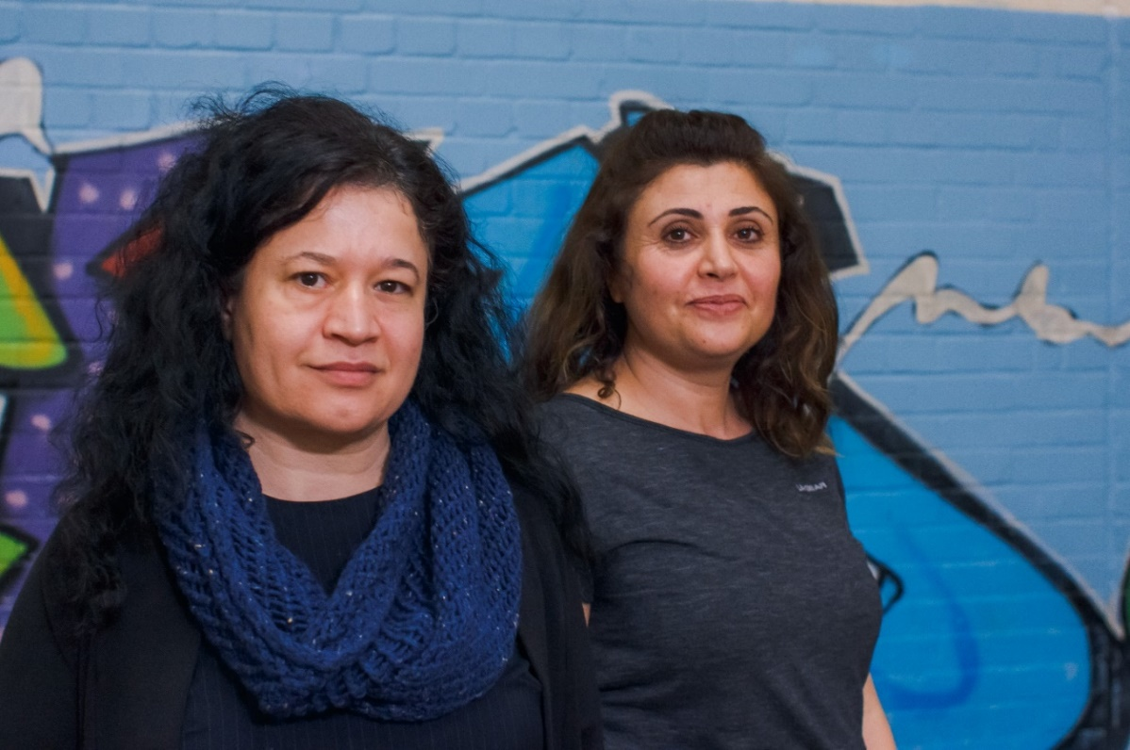

*Roj Women’s Association*

4.4 Eligible costs

Applicants can apply for the following costs in relation to the continuation or expansion of existing VAWG services, or a new element of their work in tackling VAWG:

* staffing,
* volunteers,
* equipment/small capital items,
* office/overhead/premises costs/training (i.e. core costs)
* publicity costs,
* adaptations required due to Covid-19 (i.e. risk assessments/ new equipment or technology) and/or
* training required due to Covid-19 (i.e. online safeguarding/ digital training)

LCF expects to see a balance of, and consideration for, project/service delivery costs, core costs and costs to cover engagement in the capacity-building programme. **The allocation to core costs should not exceed 50%**. Core costs can include day-to-day running costs such as office overheads, bills, rent, insurance, systems, training and salaries.

The application guidance notes on our [website](https://londoncf.org.uk/grants/vawg-grassroots-fund) include an example budget.

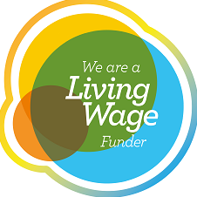4.5 Living Wage Funder

The London Community Foundation is a Living Wage Funder. This scheme, run by the Living Wage Foundation, means that The London Community Foundation aims to pay all grant-funded staff posts at or above the real Living Wage (currently £10.85 per hour in London).

**What does this mean for applicants?**

If you are applying for funding for any staff costs (this could include existing staff members, sessional workers, part time or full-time posts, freelance workers), you should budget these at the real Living Wage or above. This will be reviewed during the assessment process. We are sensitive to circumstances where organisations feel that taking up the Living Wage would cause difficulties; in these instances, please explain the circumstances in the Living Wage section of the application form. You can find out more about The Living Wage Funder Scheme [here](https://www.livingwage.org.uk/living-wage-funders).

1. Benefits of the programme

The VAWG Grassroots Fund is built on the desire to respect the expertise and insights of successful organisations. Please see Appendix F for a summary of the insights from our co-design sessions with 70 VAWG grassroots organisations. A key part of the Fund’s objectives is building the resilience of organisations, building networks and sharing best practice. This means each successful applicant will be expected to engage in the wider programme. Applicants should consider this commitment and how they want to engage before applying to the Fund.

The programme of capacity building activities, peer-to-peer events and evaluation will be co-produced with the successful grantees following the award and will include digital engagement methods. LCF recognises that this requires a time commitment. Therefore, we recommend you allocate a minimum of half a day each month throughout the two-years to participate, and budget accordingly. Engagement in the Programme will be dependent upon individual circumstances, existing organisational capacity and the size of grant awarded.

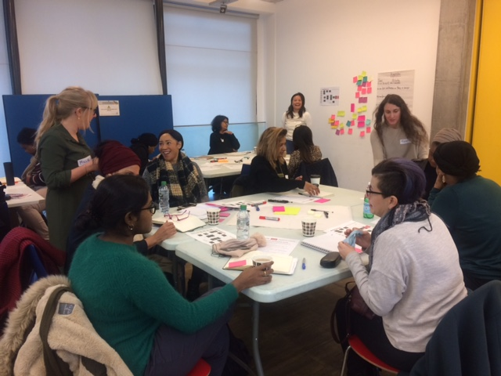

Co-design session with VAWG grassroots organisations, LCF and TSIP

5.1 Capacity building

A survey to assess the specific requirements of your organisation will need to be completed by successful grantees following grant award along with participation in at least one co-design and networking session between April 2021 – October 2021. This will be followed by involvement in a combination of optional and mandatory events delivered through webinars and face to face, depending on your specific needs.

Due to the Covid-19 pandemic and related social distancing measures, it is likely that initial sessions will take place virtually via technology including Zoom and Miro. We will endeavour to find alternative methods of engagement where there are barriers to accessing digital technology. We will review this method of engagement periodically in line with Government guidance.

At our virtual Fund co-design session in May 2020, we received positive feedback for the use of online engagement tools, as they allowed for helpful network and discussion. LCF and our partners on this Fund are committed to fostering close working relationship with the portfolio of grantees to enable greater learning.

5.2 Networking and peer support

LCF, TSIP and MOPAC are committed to learning from the expertise, insights and perspectives of grantees on the Fund. We also seek a willingness to learn from and share with other grantees and explore opportunities for collaboration to improve impact for beneficiaries. This will include optional attendance at networking events and a commitment to engage with a grantee newsletter, facilitated by LCF to platform your work and promote your voice. Those responsible for overseeing the governance of your organisation will also be expected to participate in a mid-programme networking event for board/management committee members.

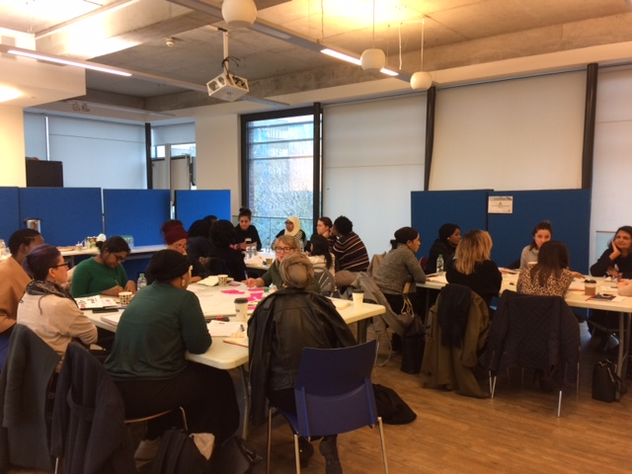

Co-design session with VAWG grassroots organisations, LCF and TSIP

6. How to apply

6.1 Initial eligibility checker and application form

There is a two-stage process for applications. All applicants must answer a few short questions about their organisation and proposal to ensure they are eligible before being invited to complete a full application form.

We understand the capacity challenges of small organisations and anticipate a high demand for funding. LCF wants to be a responsible funder, maximising success rate at full application stage, so has introduced an eligibility checker to reduce the time commitment on ineligible applicants by providing only eligible applicants with access to the full application form.

**Please** [**click here**](https://www.surveymonkey.co.uk/r/VAWGGrassroots) **to complete this short form.**

You should receive a response within 48 hours. If you are not able to access this form please contact on [VAWGGrassrootsFund@londoncf.org.uk](mailto:VAWGGrassrootsFund@londoncf.org.uk) / 020 3982 8803 to discuss alternative options.

**If eligible for the Fund:**

You will receive a link to register for access to an online application form. Please click this link and then read the instructions carefully.

**If ineligible for the Fund:**

You will receive an email explaining the reason why. LCF manages a range of other funds dedicated to supporting grassroots organisations that your organisation might be eligible for. Please [sign up for the newsletter](http://survey.clicktools.com/app/survey/go.jsp?iv=9yjo3m00tlct) and it will signpost you to other appropriate funding sources.

6.2 Application guidance

Please visit our [website](https://londoncf.org.uk/grants/vawg-grassroots-fund) to download a Word document detailing the key application questions, word counts, help notes and example responses. Please note this is a guidance document and not the application form. Answers to these questions will not be accepted in lieu of an online application form.

If you are not able to access this form please contact [VAWGGrassrootsFund@londoncf.org.uk](mailto:VAWGGrassrootsFund@londoncf.org.uk) / 020 3982 8803 to discuss an

alternative method and support for your submission.

You can save your application and come back to it to complete at any time before the closing date. You must remember to press the save button before closing.

**At the end of the application you will be asked to upload the following supporting documents:**

* Your governing document (e.g. constitution or memorandum and articles of association)
* Annual accounts for the latest completed financial year
* Safeguarding policies

Names and addresses of those individuals responsible for the governance of the organisation: Trustees / Directors / Management Committee as appropriate

* Organisation’s financial projections and secured income for the current financial year. We recognise that grassroots organisations have been disproportionately impacted financially by the COVID crisis, at a time when need for services has significantly increased. We recognise that the financial resilience of organisations applying to the Fund will now look very different. We have included a Financial Sustainability Model [link to be embedded] with Guidance as part of the application process. This document is both to help LCF understand the financial position of all applicants to the Fund and provide additional support to individual applicants to identify key areas of financial risk and how your organisation is responding to these, as part of your application. Financial resilience is one part of how we will assess applications to the Fund alongside, for example, track record of delivery, engagement and reach to target service users and understanding of your community as you define it. This Fund is committed to looking at the wider organisation, its value and impact to women and girls already accessing the VAWG services and its financial security to continue to deliver services to women and girls impacted by violence. We ask you to be as clear and informative as you can about your financial position so we can support your application
* Partnership agreement (or equivalent document) for organisations applying in partnership

LCF requires that all requested documents are submitted before the deadline for your application to be considered. Please get in touch with LCF as soon as possible if you experience any problems in attaching key documents.

**Important!**

**LCF recommends that you draft your responses in a Word document before completing the online form and ask somebody to read through your answers before sending, preferably someone who knows nothing about the project. This is a great way to pick up on any mistakes or lack of information and rectify it before submitting.**

6.3 Applicant support and FAQs

LCF is running a range of applicant support options for eligible applicants including group webinars, telephone surgeries and live twitter chats.

Please [click here for a live list of Frequently Asked Questions](https://londoncf.org.uk/blog/vawg-grassroots-fund-faq).

We aim to provide easy access for all users to our website and to ensure that users can experience all content on the site, regardless of their browser and operating system. Please [visit our accessibility advice page](https://londoncf.org.uk/accessibility) for details. The VAWG Fund Coordinator and Manager can provide applicant support.

**If you have additional support needs, please contact us:**

**Email:** [VAWGGrassrootsFund@Londoncf.org.uk](mailto:VAWGGrassrootsFund@Londoncf.org.uk)

**Phone:** 020 3982 8803 and ask to speak to the VAWG Fund Coordinator.

1. Assessment and decision making

7.1 What happens after the Fund deadline?

The VAWG Grassroots Fund is seeking to redress the imbalance of funding to the grassroots sector. The unique and trusted role grassroots organisations have in their communities is paramount and will be valued as such, as reflected in the assessment framework (section 7.4). This will be considered alongside potential organisational or financial risks faced by applicants as a result of the wider funding environment.

The eligibility of each applicant will be checked (see Appendix G: eligibility and due diligence). This will be followed by a shortlisting process (see Appendix H: Shortlisting Framework) which is based on the Fund priorities and takes into account assessors’ knowledge of the applicant’s track record, the wider VAWG context and an understanding of the grassroots sector. This means that LCF recognises that the grassroots sector mostly operates without professional fundraisers and more frequently where English is not the first language of the individual writing the application.

Applications will be shortlisted according to the minimum of 60% and maximum of 40% funding split and assessed against the Fund’s priorities and how well the proposal meets the aims of the Fund. Applications will be scored according to the Assessment framework (section 7.4). The percentage weighting emphasises the most important parts of the application. Both numerical scores and an informed understanding of the needs and existing capacity of grassroots organisations will be taken into consideration.

The decision-making panel including VAWG experts (with BME representation) will meet to review the full assessments of shortlisted applications.

* Shortlisting and assessment will take place in mid-January/February 2021
* If your application is shortlisted, you will receive a call from a grant assessor to discuss and clarify any necessary parts of your proposal.
* For grant requests over £60,000 (£30,000 per year) we may seek to engage with you for additional calls/information about your applications as part of the assessment process. Due to current Covid-19 social distancing guidelines, this meeting will likely be virtual.
* The panel will meet in March 2021 to make decisions about which applicants will receive funding.
* Successful and unsuccessful applicants will be notified of the decision by email in March 2021.

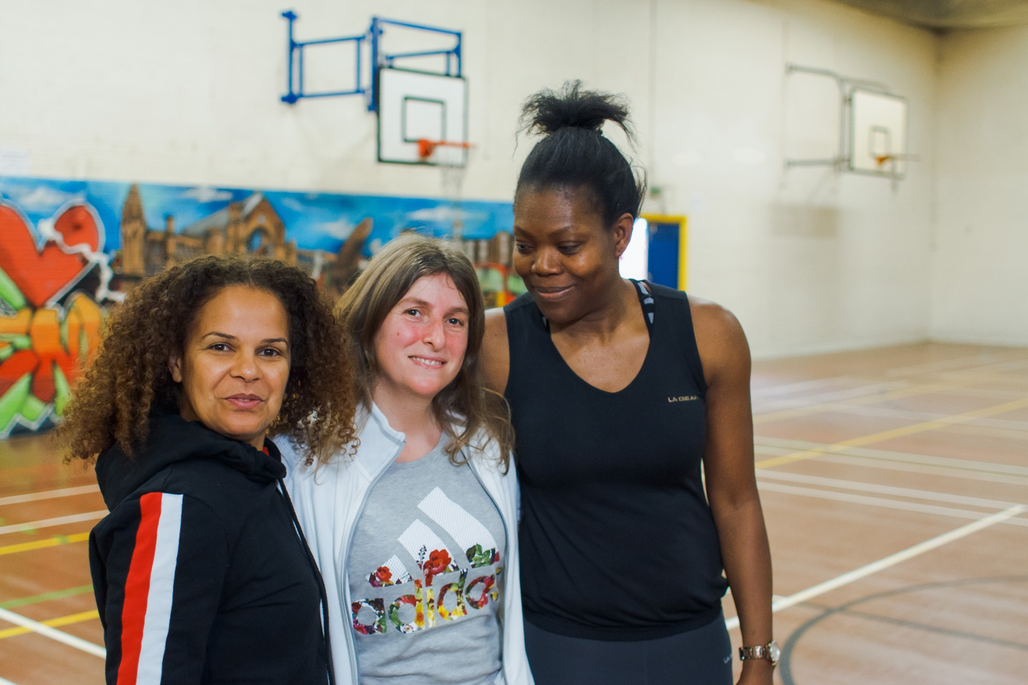

Roj Women’s Association gym session

7.2 Assessment framework

|  |  |
| --- | --- |
| **Assessment Framework** | **Weighting** |
| **Track record** of successful delivery, service user-led or high involvement. Evidence that they are working with local people and know the community. Existing formal or informal relationships with local networks and stakeholders and different types e.g. referrals, signposting or project specific.  For partnership applications, evidence of an existing relationship e.g. status of partnership agreement. | 20% |
| **Need/demand**. How the activity meets a need in the community and evidence for this. How the organisation takes an intersectional approach to addressing need. | 25% |
| **Plan**. Realistic, deliverable and proportionate, considering number of estimated beneficiaries, number of staff and intensity of support. | 15% |
| **Budget**. Realistic and itemised, with clarity on where/how the money will be spent. Consider value for money in terms of numbers benefitting from service delivery and fair cost of bespoke/intensive support for particular groups. Consideration of core costs/full cost recovery and engagement in the capacity building programme. | 10% |
| **Impact**. Clear demonstration of what they want to see change, for both service users and the organisation, and that there are plans in place to measure this. Demonstration of an awareness of the programme’s Theory of Change (Appendix E) and [Mayor’s VAWG Strategy](https://www.london.gov.uk/mopac-publications/mayors-violence-against-women-and-girls-strategy-2018-2021) and how the proposed project fits with this. | 25% |
| **Sustainability/resilience**. That there are plans to sustain the service beyond this grant. E.g. partnerships, match funding, development pipeline, upskilling volunteers, staff retention to ensure consistent provision for the community. That the organisation will be in a stronger position once the funded project has been complete. | 5% |

|  |  |
| --- | --- |
| **Score** | **Description** |
| 0: No response | No response provided |
| 1: Unsatisfactory | No real evidence |
| 2: Poor | Requirement not met and unacceptable |
| 3: Satisfactory | Not met exactly but acceptable |
| 4: Good | Most aspects of requirement are met |
| 5: Excellent | Meets requirement exactly |

7.3 What happens after grants are awarded

|  |  |
| --- | --- |
| Activity | Date |
| MOPAC to make a public announcement of successful grantees | March 2021 |
| Calls with successful applicants to support their entry onto the Fund | March 2021 |
| Grant offer letters, Grant Agreements and an organisational needs-analysis survey sent to grantees | March 2021 |
| First payments to grantees anticipated | April 2021 |
| A launch and networking event for successful grantees will take place in the evening | May/June 2021 |
| Capacity building and evaluation co-design sessions start | May/June 2021 |
| Group telephone conferences/webinars, networking and peer support events to be held | Throughout the funding period |

1. Monitoring and reporting on your grant

Monitoring and reporting on your funded work is important both for your own learning and planning and for helping us to learn from your expertise and experience to influence the design of future programmes.

Grantees will be required to complete proportionate, twice-yearly online monitoring forms (with accessible alternatives to online form available) linked to funding instalments. There will be dedicated telephone and email support to help grantees complete their reports. Grantees will receive all links via email following award. The forms will capture a combination of project activities, budget updates, service user demographics, referrals, outcomes for users/survivors, case studies, organisational learning and details of any additional funding secured during the reporting period.

Monitoring forms will also ask about your experience with the grant-making process and the service you receive from LCF and MOPAC.

LCF, MOPAC or TSIP aim to visit or speak via telephone to all funded organisations over the lifetime of the grant.

Further information and tips on monitoring your work can be found via The Charities Evaluation Services Website: <https://www.ncvo.org.uk/practical-support/consultancy/ncvo-charities-evaluation-services>.

8.1 Reporting schedule

Fund co-design participants told us that grantees should not be required to report more than two times per year. Interim reports will be due ahead of the fund instalment payment in recognition that small organisations often need to closely manage cash flow. For more insights from these sessions see Appendix F.

|  |  |
| --- | --- |
| Milestone | Date |
| Grant Start Date | 1st April 2021 |
| Year 1 Interim Report | 15th October 2021  (to enable next payment in November 2021) |
| Year 1 End of Year Report | 15th April 2022  (to enable next payment in May 2022) |
| Year 2 Interim Report | 15th October 2022  (to enable next payment in November 2022) |
| Grant End Date | 31st March 2022 |
| Year 2 End of Grant Report | 31st May 2023 |

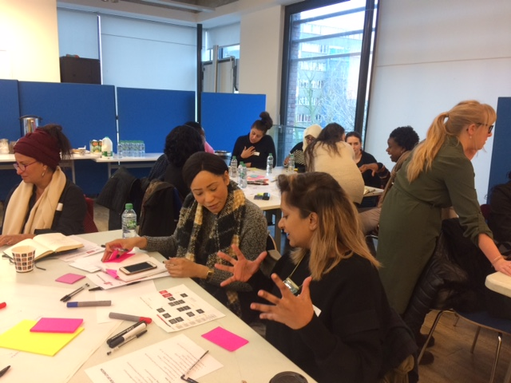

Co-design session with VAWG grassroots organisations, LCF and TSIP

8.2 What to do if things are going well, or not so well

LCF will issue successful organisations with the relevant funder logos to be used on any publicity in connection to the funded project. We recognise uncertainties presented by Covid-19, even more so for the target organisations for this Fund. We encourage successful grantees to use social media and local/community media to promote your funded project.

The hashtag to be used in connection with this Fund on social media is #VAWGGrassrootsFund / our Twitter handle is [@London_cf](https://twitter.com/London_cf)

Please let us know of any key dates or case studies in connection with the funded project where appropriate so we can include them in the monthly newsletter to help promote your organisation and project to other organisations and funders.

We aim to build a relationship with grantees and encourage you to get in touch as soon as possible if things aren’t going well. We know things change, and we aim to support any changes needed to achieve the best impact for your service users.

We know Covid-19 has placed incredible uncertainty on the grassroots sector and as a funder we want to support as best we can. Letting us early know about problems your organisation might be facing which could impact your financial position or delivery on the grant is important, for us and for you. Letting us know early on means we can work together to find a solution.

8.3 Data management

All information pertaining to the Fund and funded projects will be handled in a GDPR compliant manner. All funded projects will also be expected to abide by the requirements outlined in the Data Protection Act 2018.

1. Fund evaluation

The Mayor’s Office for Policing and Crime (MOPAC) is committed to understanding and measuring the impact of this important part of the Mayoral VAWG Strategy, both on the grassroots providers and the women and girls using their services. Evaluation of the Fund will be managed independently from MOPAC and LCF by The Social Innovation Partnership (TSIP). The Theory of Change (Appendix E) gives a picture of what we hope to achieve across the whole Grassroots VAWG Fund programme.

9.1 Engaging in evaluation

Grantees will be expected to participate in at least one co-design session to finalise a monitoring and evaluation ‘Truth Kit’. TSIP will be in touch directly with successful grantees to discuss what this process will look like after awards have been made.

9.2 Engaging service users in evaluation

In the second year, TSIP would like to speak to a small number of your service users e.g. through a focus group, telephone or face to face interviews, as appropriate and of course, with each organisation’s facilitation and individuals’ full consent. This is part of the overall Fund evaluation to understand how the programme has affected the users of funded services. All interaction with service users will be carried out in a trauma-informed way so as not to re-traumatise participants through the process.

9.3 Potential for engagement with MOPAC Evidence & Insights Team

Where appropriate, some organisations will have the opportunity to receive support directly from MOPAC’s Insights and Evidence Team who may be able to offer additional support to strengthen your organisation’s monitoring and evaluation practice. This will be offered on a case by case basis, depending on the suitability of the service and the capacity of each organisation.

“Nice to see a fund with an intersectional approach!”

1. Thank you

We would like to thank the 70 grassroots community organisations addressing VAWG that attended the five engagement events that were held from January to February 2020. A summary of insights from these sessions can be found in Appendix F.

“We need to work together to support each other but we can’t do this with limited funding pots and the low aspirations placed on grassroots.”

 ”It was a great opportunity to network with women doing similar work, as well as to contribute   
and learn.”

“When a larger charity is successful in a bid or funding application, it would be good for the funders to ask them to evidence how they are working with grassroots fairly and effectively, funders could ask the grassroots what they think (independently) to ensure lip service is not provided.”

“It’s quite a struggle at the moment to keep visible because of the changing funding structures so it’s about strength, it’s about sustainability, it’s about visibility.”

1. Contact details

Please do not hesitate to contact us if you would like to discuss your proposal prior to making an application, if you need assistance with completing the form or providing the supporting documents, or require an alternative format for this information:

[VAWGGrassrootsFund@londoncf.org.uk](mailto:VAWGGrassrootsFund@londoncf.org.uk) / 020 3982 8803

You can also find links and tools useful for exploring all aspects of setting up and running an organisation from The London Community Foundation website at: <http://londoncf.org.uk/apply/resources>

For further details on the MOPAC Victim’s Fund, please contact the Victim’s Fund Programme Manager:

[Victoria.napier@londoncf.org.uk](mailto:Victoria.napier@londoncf.org.uk) / 020 3982 8802

12. Comments and complaints

The London Community Foundation is committed to providing a quality service and achieving the highest standards of conduct. One of the ways in which we can improve our service is by listening and responding to the views of our customers.

**Therefore, we aim to ensure that:**

* Making a complaint is as straightforward as possible
* We treat a complaint as any clear expression of dissatisfaction with our service which calls for a response
* We treat it seriously whether it is made in person, by telephone, by letter, by fax, or by e-mail
* We deal with it promptly and politely
* We respond in the right way - for example, with an explanation, or an apology where we have made mistakes, or information on any action taken etc.
* We learn from complaints and use them to improve our service

Please note that grant award decisions are final and will not be revisited or overturned.  This policy, therefore, relates to expressions of dissatisfaction about the quality or nature of our service.

**If you need to raise a complaint, please contact:**[**complaints@londoncf.org.uk**](mailto:complaints@londoncf.org.uk?subject=Complaint)**.**

Appendix A: Glossary

|  |  |
| --- | --- |
| Term | Definition |
| Applicant(s) | Grassroots organisations who apply for funding from the VAWG Grassroots Fund |
| Beneficiaries | Individuals who get support from, or otherwise benefit from, the delivery of the projects e.g. service users, clients |
| BME | Black and Minority Ethnic communities |
| By and for sector | VAWG specialist organisations led by and for the women they support |
| Communities | In this context, groups of women and girls, who may or may not live in the same local area but who are connected by their social identity and shared concerns |
| Core costs | The overhead costs of an organisation, as opposed to those specific to a project. We include here costs such as rent and utilities. These costs don’t directly produce outputs of charitable activity, but they are necessary to deliver these activities. |
| Capacity-building | The terms capacity building or capacity development describe a range of activities you might use to expand or strengthen your organisation. The United Nations has defined capacity as the ability of individuals, institutions, and societies to perform functions, solve problems and set and achieve objectives in a sustainable manner. That is the basis of any well-functioning organisation. |
| CSA | Child Sexual Abuse |
| DA | Domestic Abuse |
| FGM | Female Genital Mutilation |
| Gender-informed | Services designed and delivered with the consideration of specific needs based on gender and an understanding of women’s lived experience of inequality |
| Grantees | Grassroots organisations who are successful in receiving funding from the VAWG Grassroots Fund |
| Grassroots Organisations | Organisations rooted in and led by the communities that they serve |
| IDVA | Independent Domestic Violence Advocate |
| Intersectionality | A way of understanding and analysing the complexity in the world, in people and in human experiences. When it comes to social inequality, people’s lives and the organisation of power in a given society are better understood as being shaped not by a single axis of social division, be it race or gender or class, but by many axis that work together and influence each other. Intersectionality as an analytical tool gives people better access to the complexity of the world and of themselves (Collins, Patricia Hill. et.al. 2016. Intersectionality).  Intersectionality identifies how forms of oppression are interconnected. Intersectional analysis considers how power is manifested, distributed, who has and who is affected by it. With intersectionality, power dynamics are discussed as   * How people relate to one another in increasing racial and ethnic diversity * How power is organised (encountering different treatment and how rules are implemented) * How power exists in the cultural domain which covers ideas covering social inequality and fair play and how diverse views come into the framing of the problem * And ultimately, the structural domain of power |
| LCF | The London Community Foundation |
| LBTQ+ | Lesbian Bisexual and Transgender including other Queer identifying people |
| MARAC | Multi Agency Risk Assessment Conference |
| Minoritised groups | Individuals defined as BME women and girls in public policy, LBTQ+, disabled people, Gypsy & traveller, NRPF |
| MOPAC | The Mayor’s Office of Policing and Crime |
| Needs-Analysis | An exercise to identify what training or support an organisation needs to meet its mission |
| NRPF | No Recourse to Public Funds |
| Survivors | Term used primarily to describe individuals having suffered domestic or sexual crimes. |
| SV | Sexual Violence |
| TSIP | The Social Innovation Partnership |
| VAWG | The current Government accepted definition of Violence against Women and Girls is: any act of gender-based violence that results in or is likely to result in physical, sexual or psychological harm or suffering to women or girls, including threats of such acts, coercion or arbitrary deprivation of liberty.  **VAWG can include but is not limited to:**   * Domestic violence and abuse, including coercive control * Harmful practices, including FGM, forced marriage and so-called ‘honour’ based violence * Rape and sexual violence * Sexual exploitation and prostitution * Trafficking * Stalking * Sexual harassment and misogyny   LCF recognises the above under the framework outlined in the Istanbul convention which understands VAWG as a violation of human rights and form of discrimination against women. |

Appendix B: VAWG statistics

* There has been an **increase in the need for VAWG services due to the Covid-19** and subsequent lockdown ([Women’s Resource Centre, 2020](https://www.wrc.org.uk/Handlers/Download.ashx?IDMF=a1f51f03-fb60-4dab-b352-c2cb54bd0552)). **Calls to the National Domestic Abuse Helpline (NDAH) increased by 25%**, while hits to the [national domestic abuse website](https://nationaldahelpline.org.uk/) increased by 150% during initial stages of Covid-19 lockdown (w/c 30 March), (Refuge, 2020). Alongside these increase survivors reported an **increase in barriers to accessing support** ([Women’s Aid, 2020a](https://www.womensaid.org.uk/wp-content/uploads/2020/05/The-impact-of-Covid-19-on-survivors-findings-from-Women%E2%80%99s-Aid%E2%80%99s-initial-Survivor-Survey.pdf)).
* Access to escape and support networks were restricted during COVID-19 lockdown measures. Over 60% of survivors surveyed (who were experiencing abuse at that point) stated COVID-19 made it **harder for survivors to access specialist domestic abuse services**. (Women’s Aid, 2020a).
* Amidst the COVID-19 first wave outbreak, 22% of **VAWG services surveyed reported they were unable to effectively support adults victims of abuse** and 42% were unable to effectively support child victims of abuse ([SafeLives, 2020](https://safelives.org.uk/sites/default/files/resources/SafeLives%20survey%20of%20frontline%20domestic%20abuse%20organisations%20for%20COVID-19%2030.03.20_0.pdf)). Furthermore, 84% (38 out of 45) of service providers and 36% (12 of 33) of **refuge providers reported having to reduce or cancel one or more services** ([Women’s Aid, 2020c](https://www.womensaid.org.uk/wp-content/uploads/2020/05/The-impact-of-Covid-19-on-domestic-abuse-support-services-1.pdf)). (Survey conducted 24-27 March 2020, 119 VAWG services responded.)
* **Minoritised groups** (BME, LGBTQ+, trafficking victims and people with no recourse to public funds (NRPF)) **need** **targeted services** as they are more likely to experience longer-term impacts of COVID-19 i.e. unemployment ([House of Commons Home Affairs Committee, 2020](https://publications.parliament.uk/pa/cm5801/cmselect/cmhaff/321/321.pdf); [Imkaan, 2020](https://829ef90d-0745-49b2-b404-cbea85f15fda.filesusr.com/ugd/2f475d_6d6dea40b8bd42c8a917ba58ceec5793.pdf)).
* There was an increase in complexity in DA cases due to the COVID-19 outbreak, in addition to **reduced capacity of suitable emergency refuge accommodation** (e.g. due to initial concerns over managing the spread of COVID in communal accommodation; a lack of personal protective equipment (PPE); reduced/lack of access to interpreters to support women who need them) ([Women’s Aid, 2020b](https://www.womensaid.org.uk/wp-content/uploads/2020/08/A-Perfect-Storm-August-2020-1.pdf)).
* 95% of those going to Multi-Agency Risk Assessment Conference (MARAC) or accessing an Independent Domestic Violence Assessment (IDVA) service are women (SafeLives 2014, 2015). **Individuals with disabilities, BME communities, LBTQ+ victims and those with NRPF face additional barriers in accessing services** (MOPAC, NHS England, 2016).
* **DA and SV survivors are predominately female**. Women are more likely to have experienced domestic abuse (5.9% compared with 2.9% of men, equating to ~164,000 women and ~82,700 men using London population estimates and 2017 Crime Survey for England & Wales data). Women are also more likely to have experienced sexual violence (4.1% compared with 1.3% of men, equating to an estimated ~114,000 women and ~37,000 men using London population estimates and 2019 Crime Survey for England & Wales data), (MOPAC, 2020).
* Just under 50% of victims are 25 years old and under.
* BME women are disproportionately represented as victims of DA and rape/SV, 20% 18% respectively, compared to 16% in the wider population.
* Under-reporting across all VAWG crime types is still significant.
* Demand for services is increasing which is posing a challenge to services
* Inner London boroughs are the most affected by VAWG, (Beneath the Numbers, MOPAC, 2018).
* 117 reports of FGM in London, highest across the U.K. (NHS Digital, 2018).
* 290 reports of honour-based violence, highest across the U.K. (Metropolitan Police Service, 2018).
* The London Rape Review (led by the London Victims Commissioner, MOPAC, 2019), found 41% of reports involved survivors with multiple needs & mental health issues. This is coupled with 45% of survivors being classified by the police as vulnerable.

Appendix C: Funding split examples

|  |  |
| --- | --- |
| **A minimum of 60%** | **A maximum of 40%** |
| **Organisation A:** A refuge by and for Latin American women and children fleeing gender-based violence. They offer holistic and intersectional services ranging from refuge homes, advice and support, crèches, counselling, empowerment programmes and housing support. Their aim as an organisation is to work together with Latin American and other black and minoritised women and children to end violence and achieve self-determination. | **Organisation V:** A charity run by disabled people for disabled people, who provide specialist and holistic advocacy and support services to disabled people from diverse communities in London who are victims/survivors of domestic or sexual violence, hate crime, harassment and other forms of abuse. |
| **Organisation B:** A woman-only centre which aims to empower BMER women, particularly Turkish, Kurdish and Cypriot women. Their vision is a society where all BMER women and girls can pursue their dreams and enjoy their lives free from all forms of violence, discrimination and prejudice. They deliver holistic services which support women to assert and enjoy their rights and achieve their aspirations. | **Organisation W:** A holistic lesbian and gay centre that offers a range of social, emotional and support services to LGBT communities. They are a community-led organisation which aims to promote the mental health, wellbeing, empowerment and equality of LGBT communities. Their core work includes young people’s services and counselling, including for LGBT victims of violence. |
| **Organisation C:** They are run by and for Asian women with the aim of saving lives and safeguarding future generations from domestic abuse. The organisation provides support and services to help women in the rescue, rehabilitation and rebuilding of their lives after the trauma of abuse. They are committed to addressing and reforming the social structures and cultural conditions that allow violence and abuse to persist in the community. | **Organisation X**: A Centre that provides information, advice and support to people from Central and Eastern Europe. They provide frontline delivery of information, advice and advocacy for disadvantaged Eastern European migrants in need of help to navigate British systems, develop confidence and skills, and improve integration with the British society. Their services include supporting female victims of sexual violence, trafficking and modern slavery. |
| **Organisation D:** A community-based initiative that supports African heritage women and girls who have experienced domestic or sexual abuse and those who have lost a loved one to domestic violence. They also work in their local community to raise awareness of domestic and sexual abuse. They assist those who are apprehensive about going to mainstream services. | **Organisation Y:** A Centre that supports women involved in prostitution. They are a women-only space and offer a range of support services including support to exit prostitution, health and wellbeing services and outreach and advocacy. |
|  | **Organisation Z:** A specialist women’s charity that delivers support services to women from a range of backgrounds. They work with women survivors of domestic abuse and sexual violence across London, particularly those experiencing multiple disadvantage. Their services are women-focussed, holistic, user-led and intersectional. |

Appendix D: Grant size examples

Here are some examples to illustrate recommended grant requests:

**Example A**

The applicant organisation had an annual income of £600,000 in the last financial year and demonstrates their organisation has been impacted by Covid-19 or are uniquely placed to deliver their proposed service, so can apply for any value up to £100,000 (£50,000 per year).

**Example B**

The applicant organisation had an annual income of £80,000 in the last financial year but can provide evidence of a secured income of £110,000 in the current financial year. The applicantcan therefore apply for any value up to £100,000 (£50,000 per year) on the basis of this evidence.

**Example C**

The applicant organisation had an annual income of £30,000 in the last financial year so is encouraged to apply for no more than £15,000 in the first year of funding.

**Example D**

The applicant organisation had an annual income of £20,000 in the last financial year and so is ineligible to apply for the minimum value of £15,000 per year. However, the organisation had an unusually low income in the previous year and can demonstrate a higher income for the preceding two years and/or a higher expected income for the current or future financial year. In this case, the applicant should call LCF’s VAWG Fund Manager before applying.

Appendix E: Theory of Change

The following two pages illustrate the changes we hope to achieve together with grantees, both for the resilience of the VAWG community sector and ultimately, for the lives of women and girls affected by violence. Frontline organisations who deliver VAWG services co-designed this Theory of Change. The Assumptions which follow are the set of conditions needed for these changes to be realistic.

This Theory of Change gives a picture of what we hope to achieve across the whole Grassroots VAWG Fund programme, not what each individual grantee needs to monitor or respond to. However, applicants should show how their work will contribute to the overall aims of the Fund, which are outlined in the Assessment Framework (section 7.2) and pictured in the Theory of Change.

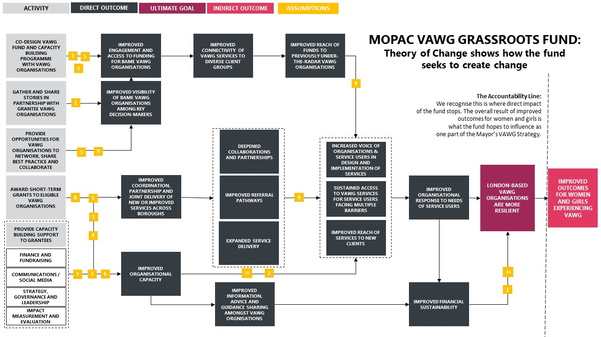

**Assumptions:**

**The conditions needed for the VAWG Grassroots Fund to create change**

1. Activities of the Fund will prioritise contacting and reaching underrepresented VAWG organisations, especially those that are BME-led (60/40).
2. The Fund will work in partnership with grassroots organisations and insights from the co-design sessions are accessible to participants.
3. The Fund’s activities are accessible and appealing to VAWG grassroots organisations, in their context and in their language.
4. The Fund’s activities build trust to deeply engage, share learning and experiences (stories) of VAWG organisations (especially those not heard before).
5. VAWG voices (either organisations or users/beneficiaries) are represented throughout the Fund and wider Programme – including in decision-making processes.
6. Activities and outcomes are targeted and mindful of VAWG organisations’ varied contexts and experiences.
7. Grantees and participants have the capacity, support, resources and motivation to apply the knowledge and skills they share and learn.
8. Funding decisions are not influenced by politics or other power dynamics.
9. Activities and funding decisions encourage peer-to-peer learning and appropriate collaboration.
10. Activities make a meaningful difference and contribution to funded organisations and, indirectly, to their users/beneficiaries.

Please note the Theory of Change was produced prior to the Covid-19 outbreak.

Appendix F: What we heard from you

Working in partnership with grassroots organisations is the foundation of this Fund. Over 70 grassroots organisations delivering VAWG services took part in sessions and calls with LCF and TSIP between January and February 2020. The purpose was to co-design the VAWG Grassroots Fund and programme. Below is a summary of their insights:

**The Prospectus**

* The application process must be accessible and inclusive, with a range of support options available, including simple and sector-appropriate forms. The Prospectus and application forms should include sample responses and a list of required documents for reference.
* The criteria and scoring process should be transparent.
* VAWG experts and majority BME representation should make up the majority on the Decision-Making Panel for the Fund.
* The Fund must award flexible grants for both core and project costs, and financial status should not be the sole determinant of a funding award.
* The Fund should not be dedicated to one VAWG priority, but should award grants to fund long-term preventative work, as well as crisis response.

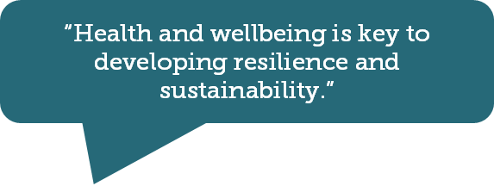

“[Organisational resilience is…] about making sure that we can think ahead to help them (survivors) in the future and to get them on their right road, to get them supporting themselves and do what they need to do.”

**Peer learning, training and support**

* The needs of grantees must shape the capacity building programme. If grantees need to attend in person, sessions must be held locally or online, and should be remunerated.
* Grantees should be able to access different support related to long-term funding strategy, business planning and governance, as well as back office support, including an online resource hub with bespoke tools and software.
* Grantees must have the chance to network with key decision-makers, like other funders, larger VAWG organisations, universities and policymakers. And the programme should emphasise, encourage and facilitate partnership working across the sector.
* Supporting frontline staff health and wellbeing should be addressed in the Programme, including coaching, mentoring, clinical supervision and wellbeing events.

“As a VAWG grassroots organisation and in a situation where there’s a lot of funding cuts and difficulties for small organisations like ours, organisational resilience is mainly about surviving the economic shocks that we actually face.”

**Impact story and monitoring**

* Evaluation support should take different forms and be led by organisational need, recognising the need for different measurement for crisis intervention and long-term support.
* Grantees should not be required to report more than two times per year, and the reporting method should include one easy template or tool. Reporting should encourage and reward honesty and be gender- and trauma- informed.
* Funding for monitoring and evaluation should be ringfenced as part of application budgets, with extra or additional £ to bring in volunteers, advisors, etc. to support evaluation.
* LCF and MOPAC should include different options for face-to-face visits or phone calls to witness the impact of services first-hand.

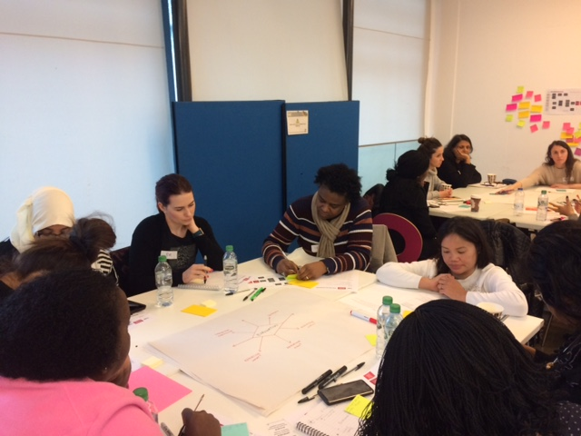

Co-design session with VAWG grassroots organisations, LCF and TSIP

Appendix G: Eligibility and due diligence

|  |
| --- |
| **Do the supporting documents submitted for the organisation demonstrate that the applicant meets the following financial and governance regulatory checks?** |
| Organisation’s Annual Accounts:   * Showing income received by the organisation is from more than one source * Showing assets outweigh liabilities for the last two financial years |
| Bank Account in organisation name |
| Governing Document demonstrating that the applicant is one of the following types of organisation with charitable aims:   * Registered charity * Community interest company limited by guarantee * Charitable Company (Limited by Guarantee) * Charitable incorporated organisation |
| Have a minimum of 3 unrelated members responsible for the governance of the organisation; trustees / directors / management committee, as appropriate |
| Appropriate Safeguarding Policies |
| Charity Commission/Companies House registration number:   * Compliance with these bodies will be checked by LCF – no applicants with late or missing returns in the last two years will be eligible |
| Non-lead partners, if applicable: Charity Commission/Companies House compliance, Safeguarding policies and Annual Accounts |

Appendix H: Shortlisting framework

|  |  |  |  |  |  |
| --- | --- | --- | --- | --- | --- |
|  | **Organisation is run by and for BME communities** | **Gendered approach** | **To support existing ending VAWG services** | **Themes and target service areas** | **Track record of impact on service users** |
| **0** | No focus on BME communities | No evidence of a gendered approach | No evidence of link to VAWG | No priority VAWG themes addressed | No evidence of impact or reputation with service users |
| **1** | Not a specific BME organisation but reaches majority BME clients | Mainly supports women, not women-led | VAWG is one of the organisation’s service | prevention, education, historic abuse | Little evidence of previous impact, reputation in sector |
| **2** | Supports a BME community, but not BME-led | Mainly supports women, is women-led | VAWG is one of the organisation's core services | holistic support for those experiencing any form of VAWG | Some evidence of survivor testimony, ex-client volunteers, reputation in sector |
| **3** | Supports a BME community and BME-led | Run by and for women-only | Ending VAWG is the organisation's purpose | Targeted work in FGM, HBV, forced marriage, SV etc. | High level of survivor testimony, impact data, depth of reach, ex-client volunteers, reputation |

Appendix I: Victim’s Fund 2020/21

A large proportion of services for victims of crime are delivered by small voluntary, community and social enterprise (VCSE) organisations. The MOPAC Victims Fund is a small grants fund that seeks to improve cooperation and collaboration between services, with the ultimate aim of providing end-to-end victim services that run seamlessly and are led by the victim’s needs.   
  
The Fund will build the capacity and maximise the potential of VCSE organisations to support the continued and improved provision of vital services that help victims of crime to cope and recover.   
  
The total funding available for 2021/22 is £1,015,200. Grants of between £20,000 and £50,000, over one year, are available to individual organisations providing support to victims of crime to help them cope and recover from their experience. Additionally, applications from partnerships of two or more organisations, with one lead applicant, can receive up to £80,000.  
  
For more information on the Fund, please read the fund guidelines (insert link) or get in touch with the Programme Manager at: [victoria.napier@londoncf.org.uk](mailto:victoria.napier@londoncf.org.uk)

Appendix J: About us

About MOPAC

The Mayor’s Office for Policing and Crime (MOPAC) was established on 16th January 2012 under the Police Reform and Social Responsibility Act 2011. MOPAC holds the Metropolitan Police Service (MPS) to account; making the police answerable to the communities they serve. MOPAC is the Police and Crime Commissioning body for London. MOPAC is required to work in partnership across agencies at a local and national level to ensure there is a unified approach to preventing and reducing crime.

MOPAC is responsible for delivering the Mayor of London’s Police and Crime plan. More details of the work of MOPAC can be found at: <https://www.london.gov.uk/whatwe-d0/mayor’s-office-policing-and-crime-mopac>.



[](https://www.tsip.co.uk/)

About The Social Innovation Partnership

[The Social Innovation Partnership](https://www.tsip.co.uk/) (TSIP) is a diverse team of technical and community specialists who are joining forces to drive social change. They support their partners to better understand the issues they care about and increase their positive impact on people and communities. They do research, design programmes, measure impact, and facilitate strategy, learning and co-production.

About The London Community Foundation

To the Capital’s most vulnerable people, grassroots organisations can be the first place of safety, hope and support. And yet these organisations are often overlooked by much of the funding environment. The London Community Foundation (LCF) manages funds on behalf of individual and corporate donors and public sector bodies. We work to promote the unique and valuable role of grassroots organisations in London and inspire people and companies to invest in them.  We seek to promote the important ambition of grassroots providers - not to scale and replicate but to be the trusted anchors in their neighbourhoods or the place of safety for the communities they represent. Last year LCF made over 1,200 grants to grassroots organisations in the Capital, averaging £13,500.

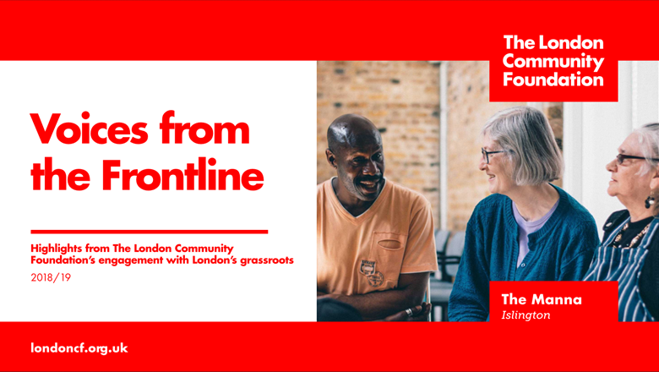In 2019, LCF conducted its largest engagement with grassroots organisations across London. [*Voices from the Frontline*](https://londoncf.org.uk/uploads/Voices-from-the-Frontline-2019.pdf) provided a picture of life on the frontline in London today, through the eyes of over 200 organisations. Almost one quarter had no full-time staff and 74% said securing core funding was their single biggest challenge.

border above London Community Foundation contact details

Unit 1.04 Piano House

9 Brighton Terrace

London SW9 8DJ

T +44 (0)20 7582 5117

F +44 (0)20 7582 4020

E [info@londoncf.org.uk](mailto:info@londoncf.org.uk)

**londoncf.org.uk**

Registered Charity 1091263