Thamesmead

Community

Fund
Online application form guidance

londoncf.org.uk



Thamesmead Community Fund – Online Application Form Guidance
(for Organisations and Individuals)

These are guidance notes for both the ‘organisation’ and ‘individual’ applications to help you complete some of the key questions in the online form for the Thamesmead Community Fund at The London Community Foundation. Most of the questions remain the same for both individuals and organisations, except Section 2 and Supporting Documents, where different information is required (see below).

Tips:
- You can also click the symbol next to question on the online form for help on how to respond.
- Each of the large text boxes will have a maximum word limit of 250 words unless stated otherwise.
- Text boxes/fields marked with a * need completing – without an answer you will not be able to submit your form.
- It is a good idea to draft your responses (particularly in Section 3) using a word processing programme such as Microsoft Word, so that you can check your spelling and word count as you go along.
- As you enter your information on the online form, remember to save your progress periodically by clicking on the ‘Save Changes’ or ‘Next’ button at the bottom of the page, to prevent you from losing your work in case of internet issues.
- Only check the ‘Mark as Complete’ box on each page when you are ready to submit the form. Ticking this button will lock your access to this section and you will need to speak to a member of LCF to regain access.

Registration on the Fundseeker Portal

The London Community Foundation has recently upgraded their Data Management system and all applications will now be submitted via the Fundseeker Portal which will hold all of your ongoing and previous applications, enabling you to refer back to them and their outcomes easily.

First, please go to the website - https://londoncf.my.site.com/fundseekerportal/s/login/

Next, you will need to register your FundSeeker Account. Unless you are already registered please click the ‘Register here’ option. Otherwise please login using your username and password.

This will take you to a new page, where it will ask you to state whether you are applying as an individual or an organisation and if you have applied to The London Community Foundation in the past. If you have previously applied, your details should be stored on our database, so we will need you to fill in some basic details to help identify you. Alternatively, you’ll be asked a couple of questions around eligibility before you can fill in your details. If you are a new applicant, you may be asked to complete further details about your organisation.

The system will then send you an e-mail to verify your address with a link you should use to create your password, before fully logging into the system where you should find three red boxes:
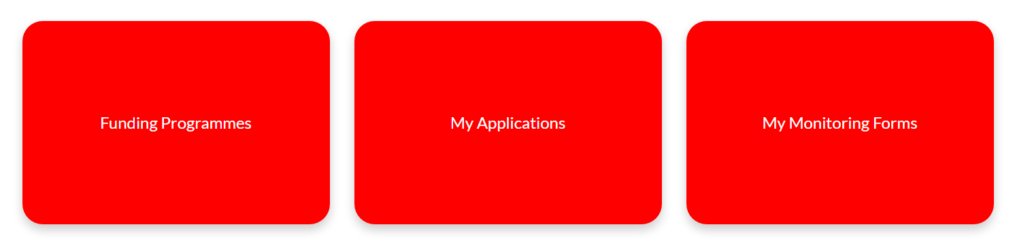
To access the application form please click on ‘Funding Programmes’ and select the programme that is relevant to you:
- Thamesmead Community Fund (Organisation) – for organisations
- Thamesmead Community Fund (Individual) – if you are applying as yourself

Please read the Fund Description carefully before clicking the ‘Apply here’ to start your application.

Section 1: Check Contact Details

Please use this section to fill in your personal details, including your Job Title and the organisations address. If you are applying as an organisation, please do not include your company name as this will be added separately. (Once these details are submitted on the portal, they should automatically update on all subsequent applications.)

Section 2: About Your Group or Organisation (for Organisations)

Organisation start date
Please let us know the month and year that your group was set up or formally established.

Social Media Information
Please provide details of your relevant social media accounts.

What type of organisation are you?
Please use the drop down menu to select what type of organisation you are and then enter the relevant registration number where applicable.

Are you part of a larger regional or National organisation?
Please use the drop-down options to indicate whether you are applying as a hub or subsidiary of a larger organisation. This will help us when we review your attached documents.

Income over the last accounting year
Please let us know your organisation’s income over the last financial year. If you are a new organisation, please tell us your actual income to date from your management accounts.

How do the people you support, or people with experience of the issues, help shape the work you do?
Please provide a brief outline of how you engage with your community to determine the aims and outcomes of your organisation.

Is your group Led By and For any of the following communities?
As we aim to support grassroot organisations who are run by people from within the community they support, please indicate whether your management committee is made up of more than 50% of said community. If your management committee is less than 50% please select ‘We are not a Led By and For group’. Use the following two boxes to give any further details about how the leadership of your organisation represents your community.

Staffing and volunteers
Please let us know how many full and part time staff your organisation employs. If applicable, let us know how many members and volunteers your organisation has. Your Management Committee may be known as your Trustee Board. (We recommend there is a minimum of 3 members). Please provide the names of all members of your management committee and their roles.

What are the aims of your organisation and what activities or services do you provide? How is your organisation run and managed? How are decisions made? Do staff who lead on your activities have valid DBS checks?
Please tell us about your organisation’s aims, and what activity/ies you usually deliver, for whom and where. How is your organisation run and who manages it? How are key decisions made? Please explain your organisation’s usual activity and management structure. Do staff running activities for children under 16 or vulnerable adults have valid and up-to-date DBS checks?

Please provide the bank details where you would like the grant to be paid into should you be successful in your application.
Bank accounts should have at least two unrelated signatories and preferably three. These details will be checked against your bank statements should the grant be released to ensure it is being paid into the correct account.

Press ‘Next’

Please describe briefly the overall aims and objectives of your organisation and the activities or services your organisation provides.
Please tell us about your organisation’s aims, and what activity/ies you usually deliver, for whom and where. How is your organisation run and who manages it? How are key decisions made? Please explain your organisation’s usual activity and management structure. Do staff running activities for children under 16 or vulnerable adults have valid and up-to-date DBS checks?

Mark as Complete
While you will need to check this box to submit your application form, only do this when you are sure the section is complete as you won’t be access it easily once you have saved the section.
*Please note that these details within this section will be stored on our database and will appear on future applications automatically.

Section 2: Your Bank Details (for Individuals)

If you are applying as an individual the second section is simply for you to enter your bank details. This is so we have something to compare your bank statement against should you be successful in your application.

Section 3: About Your Project (for Organisations and Individuals)

Project name
Please enter the project name here, such as Thamesmead Drama Club. If the project does not have a name, please enter the name of your organisation instead.

Project funding start / end
Please put the forecasted project start and end date. Please note that successful applicants will have a maximum period of 12 months from the offer letter date to spend the grant.

Is this new work?
Please indicate whether this is a new initiative or a continuation of existing work.

Please indicate which theme best describes your proposed project: Arts & Culture, Mental Health & Wellbeing or Other Community.
Please indicate which of the following 11 themes your project aims to support:
- Increases levels of arts and cultural activity
- Supports educational outcomes for a group
- Brings the community together
- Seeks to improve local health and wellbeing
- Encourages community use of local outdoor spaces
- Supports activities to strengthen children and family relationships
- Help people develop new skills
- Provides local services or activities for older people
- Use nature of gardening to bring people together
- Provide opportunities for people to connect with and enjoy the natural environment
- Increase biodiversity in Thamesmead

You can enter more than one, but you will need to type these into the box provided.

Please tell us about your project idea, and the activities/services a grant would enable you to run.
Please tell us about your project idea, and the activities/services a grant would enable you to run. Do you have a back-up plan if Covid restrictions tighten again?

When and how often will sessions run and for how many people?
Please outline how long you anticipate your project will run, giving details of the number and duration of the sessions, and how many attendees you would expect to engage per session.

Where will you run your activities – indoors or outdoors (adhering to government Covid guidelines) or online. Do you have permission to use a venue?
Let us know whether the sessions are to be held in person or online. Please tell us if you need to hire a physical space to deliver the project and, if you have a location in mind, if you have contacted the site owners/managers.

Who will deliver the activities? Tell about us their expertise and experience.
Please provide information about the individuals running the project, including any relevant qualifications and expertise in delivering similar initiatives.

While it is no longer a requirement for applicants to have discussed their proposal with a local Peabody team member, it would be useful to know whether you have sought support from the local team and who you have spoken to.
If applicable, please provide their name and what their role is within the Peabody team and what advice they gave.

How have you identified the need for this project and are you working with any local partners to help raise awareness or support the delivery?
Please tell us if local residents have requested the proposed activities or if you ran a survey. Have you discussed the project with them? Which residents are you targeting, and what type of engagement activities will you provide? Will any partner organisations be involved?

How are you planning to recruit the participants of your programme? Is this through local partners or a marketing campaign?
We will need to understand your engagement strategy, i.e. where will the participants come from. Outline what marketing you intend to undertake, and what local partner you will use to encourage individuals to take part.

What positive change would you like the project to make? For example, will residents learn new skills, increase their confidence, make new friends, or be less socially isolated?
Please give details of the potential outcomes of your project.

How will you record these benefits/changes delivered by your project?
Please explain how you will measure the success of the programme and what tools you will use to gather the information. For example, you may be monitoring attendance of the sessions or through online surveys for local residents.

Are you a Thamesmead resident? If No, where do you live? (Individuals only)
Please answer ‘Yes’ or ’No’, and give your location with you are not. Please note that the priority for this Fund is to support Thamesmead residents’ projects.

Are you a current or past Peabody employee or volunteer, or are you related to any Peabody employees? If yes, please give details. (Individuals only)
Please answer ‘Yes’ or ‘No’ and if yes give a brief outline, giving the role title and duration.

Section 4: What Geographical Areas (For Organisations and Individuals)

Please use the tick boxes to select the local authority area where the activity will mainly take place. If the activity takes place in both Bexley and Greenwich, please select both.

Section 5: Themes and Who will Benefit (For Organisations and Individuals)

Primary Theme
Please use the drop-down function on the left-hand side of the form to select the theme that best fits your proposal. You can use the options in the right column to select any secondary themes you feel your project addresses, holding down Ctrl if you wish to select more than one.

(This section is based on The London Community Foundation framework and are standard across all programmes, so while you have already highlighted which fund themes you are working on, we also need this data to compare your impact against other projects funded by other programmes.)

Primary Activity
Use the dropdown list to select the option which best describes the nature of your proposed project.

How many people will directly benefit from this activity?
Please estimate the total number of people who will participate in / benefit from the proposed project. We realise that you may not be able to give exact figures but please estimate as accurately as possible. This information is important and will be used to evaluate the project at the end of the grant period.

How many people will indirectly benefit?
Please estimate the total number of people who will indirectly benefit from the proposal, i.e. not take part but whose lives may improve as a result of the project. This might include partners, family members, local businesses or members of the public who see an improvement to local spaces within the next twelve months.

How many of the participants will be adults (aged 18 and over)?
Please tell us the estimated number of adults who will take part in/benefit from the project.
N.B. The number of adults given in this answer and the number of children (to be answered in the next question) should equal the total number of people you estimate will benefit from the project.

How many of the participants will be children under 18?
Please tell us the estimated number of children who will take part in/benefit from the project.
N.B. The number of children given in this answer and the number of adults (answered in the last question) should equal the total number of people you estimate will benefit from the project.

Beneficiaries
From the drop-down list, please click on the one group that best reflects the majority of the beneficiaries of your organisation, this will then be entered in the selection box on the lefthand side of the form. You can then use the right-hand column to select any other relevant groups that will be affected, remembering to use Ctrl & Click to select more than one option. Please don’t select them all if they don’t apply, just think about who the primary beneficiaries will be. This doesn’t have to be 100% accurate, you’re just giving an indication.

Ethnicity
From the drop-down list, please select one ethnic group that best reflects the majority of the users of your organisation and enter it in the box provided. Then, using the left-hand column, select any other ethnic groups that will benefit. Please only tick the groups who will benefit.

Age Group
We would be interested in knowing which age groups would benefit from this grant. Please enter in the drop-down the age group that represents most of the beneficiaries of your organisation. Then, using the Ctrl & click to indicate any other age groups that will benefit.

Gender
It would be useful for us to identify any targeted support going to various genders within the community, so please use this drop to indicate if you are aiming to support a specific gender of the community as a whole, by using the ‘All Genders’ option.

Section 6: What Will it Cost (for Organisations and Individuals)

Project Budget
This section asks you to provide details regarding the amount of money you are applying for and what type of items you will be spending it on.

How much money are you applying to the Thamesmead Community Fund for?
The maximum you can ask for is £3,000, and you can request the full cost. Project costs are the priority for this Fund (i.e. sessional and activity costs), although some running costs can be requested. The total cost here should not include in-kind costs, such as free venue hire.

How much will your project/activity cost in total?
Where a project costs more than the amount you are requesting, please give the total cost here.

How much has been raised so far?
If you are not asking us to fund the full costs, how much have you raised already? If none, please enter 0 in this box.
Alternatively, where you are asking us for the total project cost, please insert 0 here.

Are you seeking other funding towards this project?
Please use the drop-down options to indicate whether you are seeking funding from other organisations.

Budget breakdown
Here you itemise the costs that will be incurred in running your project only. The headings (staff costs, volunteer costs, etc.) are examples of types of costs and the amount – you do not have to put a cost in each heading if it does not apply but there may be others that you need to include.

Since this is for project funding, we cannot provide general core funding through this grant. However, we are committed to covering the full costs of the project, including the indirect costs related to delivery. For example, while we cannot cover the full costs of a bookkeeper, we can cover an amount that is proportional to the activity taking place. This can be 5% of the annual cost, e.g., 5% of cost of an administrator to monitor the project. All application budgets will be reviewed for appropriateness so we do not have a firm minimum or maximum for overhead costs. However, typically we will expect indirect costs to be capped at 20% of the overall budget.

There are two cost boxes, one for the total project cost for that type of cost and one for the amount you are applying to us under that cost heading.

The cost breakdown also allows you to enter the details behind the cost summary. These details should only refer to the elements of the project that would be covered by a grant from us. Please give us a full breakdown of the costs as shown in the example below.

Staff Costs Breakdown
Total amount | 1,400 |  | Drama tutor @ £17.50 per hour x 2 hours per session x 40 weekly sessions = £1,400
Requested amount | 1,400

Volunteer Expenses Breakdown
Total amount | 480 |  | 2 volunteers @ £6 per session each (travel and refreshments) x 40 weekly sessions = £480
Requested amount | 480

*Note for Volunteer Expenses - Only out-of-pocket expenses can be paid to volunteers, who should submit receipts and/or proof of payment such as bus/rail tickets for your records. Volunteers should not be paid a flat rate as they will be classed as employees of your organisation.

Section 7: Supporting Documents (for Organisations)

Within this section you will see a list of eight available slots for documents to be attached. The following five must be attached for your application to be considered:
- A copy of your governing document (e.g., constitution, memorandum & articles or set of rules).
- A copy of your most recent annual accounts, or an income and expenditure sheet for your last financial period for smaller groups. For new groups, please provide a forecast for your income and expenditure for your first financial period, and a copy of a recent bank statement.
- A safeguarding policy in place that has been reviewed in the last 12 months, states it is reviewed annually, and meets the requirements as listed in our safeguarding checklist
- A copy of your Public Liability Insurance.
- A copy of the completed Risk Assessment for the required activity.

If for any reason you are not able to provide one of the required documents, please upload a document explaining why you do not have it.

Optional: There are three spaces for additional documents and photos that may support your application.

Please clearly label each document with a name of organisation and a short description of what it is: i.e. The Music House – Safeguarding Policies

Section 7: Supporting Documents (for Individuals)

Within this section you will see a list of nine available slots for documents to be attached. The following four must be attached for your application to be considered:
- Proof of address, e.g. a copy of a utility bill with your name and address on it.
- Photo ID, e.g. a copy of a driving licence or passport.
- A copy of a bank statement with your account details of where to pay funds, if your application is successful.
- A copy of the completed Risk Assessment for the required activity.

Optional: With one of the fund's main priorities being to support arts and cultural activities, applicants can attach up to 3 images to support their proposal.

If funded, and depending on the project, individuals may be required as a condition of a grant to submit: A copy of your Public Liability Insurance and safeguarding policies.

For both organisations and individuals, if for any reason you are not able to provide one of the required documents, please upload a document explaining why you do not have it.

Please clearly label each document with a name and a short description of what it is:
i.e. Name of Applicant – Copy of Gas Bill

Submit your Application (for Organisations and Individuals)

Once all of the sections are marked as complete, the ‘Submit Application’ button in the final section should become available. This will happen before you have attached the documents, so, please check that the required documents are showing as ‘Submitted’:

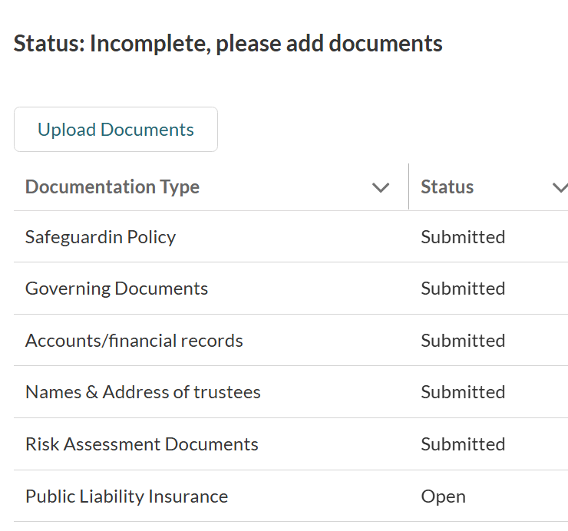

Once clicked, please read the terms and conditions and check the box if you agree with the statement. Please confirm your name and role.

How did you find the application form?
Please let us know how challenging you found the application form to complete.

When you have completed your application
Once you have completed the form, please ensure you click on the ‘submit’ button at the bottom of the page to send the application through to us. Once your form is submitted you will no longer be able to access and edit it. If you have not completed all of the required fields with a red line (to the right of the answer box), you will not be able to submit your form. If you attempt to submit an incomplete form the incomplete fields will be highlighted in red, once these are filled in you should be able to submit the form.

If you’re still not sure about anything when completing the form, please contact The London
Community Foundation on 020 7582 5117 or e-mail info@londoncf.org.uk

The London Community Foundation, Registered Charity No. 1091263 & Company Ltd by Guarantee No. 4383269
Canopi, 82 Tanner Street, London SE1 3GN. Website: www.londoncf.org.uk

