**ocument**

The London Community Foundation

Online Grant Monitoring Report Guidance

londoncf.org.uk

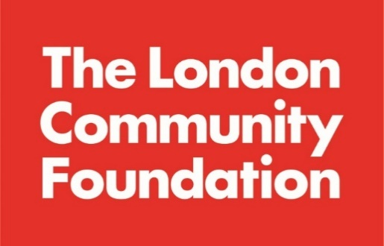

**Introduction**

In order to measure the impact of our grant programmes, most organisations that receive a grant from The London Community Foundation (LCF) will need to complete a grant monitoring form and submit to us by a set deadline. Monitoring forms help us understand the impact that funds are having, the needs of organisations we fund and the communities they work with, they help us shape future programmes and feed back to donors on what their funding has achieved. It should also help you to collect valuable information on how service users benefit from your work, what works and what doesn’t, and demonstrate to other funders the value of your work.

As a donor advised funder, we partner with over 60 unique donors with different priorities and requirements, to make funding available to community groups across London. This means monitoring requirements may differ and will be specific to each fund according to the fund criteria, your application and the type of activities that are funded. The details of what kind of monitoring you will need to submit will be stated on your unique grant offer letter.

To submit your grant monitoring report, you will need to complete an online form, the link to which will be sent to you once you have accepted your grant. It will also be automatically emailed to the named contact at your organisation, 30 days before the deadline date. Therefore, if this staff member or volunteer leaves, you should get in touch straight away to [update your contact details by clicking here](mailto:info@londoncf.org.uk?subject=Change%20of%20contact%20(or%20other%20query)).

Organisations should keep accurate and comprehensive records of your expenditure for seven years, accounting for the grant LCF has given you. If requested, you should be able to provide us withcopies of those records and evidence of expenditure of the grant, such as original receipts and bank statements. Note, you do not need to upload these to your online monitoring report.

We know how much work goes into measuring the impact of your work and want to ensure that you have all the tools necessary to complete our online form to the best of your ability. We hope that this document provides useful insight to the monitoring requirements.

**Terminology**

NPC have a [useful jargon buster here](https://www.inspiringimpact.org/what-is-impact-practice/).

**Direct Beneficiary =** ‘sometimes called a primary beneficiary, is someone who is directly involved with your project and benefits from it. Depending on your project this could be people who participated in your training, students of the school you built… The important thing is that the direct beneficiaries are connected with the project. Since they are so closely intertwined with the project, direct beneficiaries should be easy to count and describe.’

**Indirect Beneficiary =** ‘An indirect beneficiary, sometimes called a secondary beneficiary, is someone who is not directly connected with the project but will still benefit from it. This could be other members of the community or from the area or family members of the participants.’**[1]**

**Impact =** Longer-term effects of a project or organisation’s work. This can include effects on people who are beneficiaries of a project or organisation’s work, effects on those who are not direct users, or effects on a wider field such as government policy. LCF measures each programme’s impact by collecting qualitative (non-numerical) and quantitative (numerical) data from each funded organisation. Data collection is implemented by asking for information about your outputs and outcomes both during (interim report) and after the grant’s lifetime (final monitoring report).

**Outputs** = Products, services or facilities that result from an organisations or a project’s activities. For example, workshops, leaflets, case work sessions, or a brokerage service.

**Outcomes** = The changes, benefits, learning or other effects that result from what the project or organisation makes, offers, or provides. For example, the number of people who reported improved physical/mental/emotional health. Outcomes can differentiate between both hard and soft measurements depending on the type of output, see below for these definitions.

**Hard outcomes** = Outcomes that are objective, clear, and obvious. For example, involving an observable change in people’s behaviour or circumstances. For example, the number of people who reported an engagement or re-engagement with education, training, or employment as a result of the project.

**Soft outcomes** = Outcomes that are less easy to observe or measure, or which involve some form of change inside people, such as a change in attitude or a change in the way they see themselves. For example, an increase in confidence as a result of the project.

We’d recommend checking out some [useful tools on our resources page here](https://londoncf.org.uk/apply/resources).

How we use the information provided

Our Grants & Impact Team will read your online report to learn more about your organisation’s services or specific project. This generally includes:

* How you got on over the grant period (length of time from grant award to monitoring deadline)
* How you have spent the grant money
* Hearing real life stories from a person benefiting from the grant
* The difference the grant made to your beneficiaries and/or organisation
* Finding out about the challenges and key learning areas
* Any feedback for us on the fund or our processes

We may contact you about further publicity if you tick the box that says you would be happy to help with further publicity.

Capturing data helps our team identify good practice across London. Through doing so, we can highlight key issues to attract further funding from donors. We often use the data to capture trends and evaluate the impact of our work. The feedback section is also crucial to ensure we can improve our grant-making practice to best meet your needs.

Monitoring and evaluating your funded work are important not just to us and our donors, but also for your own learning, planning and future funding applications. The information you include in this form helps us to understand the impact of our work and helps us to design future programmes.

Tips on completing the form

* We’ll ask you to answer all the questions in this form unless we state the question is optional
* On the online form you can hover over the (i) symbol next to each question for help on how to respond
* There is a character limit for each large text box. This means you can only type a certain number of letters into each answer. Letters, punctuation, and spaces all count as characters. Once you’ve reached the character limit, you will not be able to type any more. Please keep your answers clear and concise.
* It is a good idea to draft your responses using a word-processing programme such as Microsoft Word, so that you can check your spelling and word count as you go along. This will also prevent you from losing your work if your computer crashes.
* Remember to save your progress regularly by clicking ‘Save as Draft’ at the bottom of the page, to prevent you from losing your work in case of internet problems.
* If you are having trouble viewing the online form, we recommend you try a different internet browser, such as Mozilla Firefox or Google Chrome. The form does not work well in old versions of Internet Explorer.

Online monitoring report examples and tips

We’d expect to see the budget fully spent and match your original budget. If you have any issues or concerns spending the full grant or you require a change in budget, contact a member of the Grants & Impact Team prior to submitting the online report.

The underspend policy will be outlined in your offer letter, so please make sure you read and fully understand this prior to accepting the grant.

Here we capture information about the Living Wage, as we are now a Living Wage Friendly Funder. This scheme, run by the [Living Wage Foundation](https://www.livingwage.org.uk/) means that LCF will actively encourage and support organisations to pay staff the Real Living Wage which at the time of writing is £11.05 per hour in London.

We are asking groups to make their applications for any staff costs at the Living Wage rates. We understand that, for some groups, paying a Living Wage can be difficult for a number of reasons, we would like to work with groups to see how we can support you to enable you to pay a Living Wage.

We capture a range of information on the grant recipients to help measure which groups are benefiting from the funding.

Examples of the qualitative and quantitative information we’re looking for:

Honest feedback on your experience with LCF is useful to help us improve.

If you have any photos/videos, detailed case studies, there is the option to upload these to the report. Please note that we require written consent from people appearing in any photos in order to publish them on our website or social media. Please [download the permission form from our Resources page here](https://londoncf.org.uk/apply/resources).

Here you will be required to upload your latest accounts and report.

For any other questions on monitoring please contact the Grants & Impact Team on [monitoring@londoncf.org.uk](mailto:monitoring@londoncf.org.uk) or 020 7582 5117.

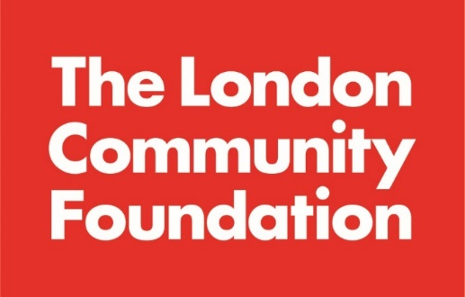



Unit 1.04 Piano House

9 Brighton Terrace

London SW9 8DJ

T +44 (0)20 7582 5117

F +44 (0)20 7582 4020

E [info@londoncf.org.uk](mailto:info@londoncf.org.uk)

**londoncf.org.uk**

Registered Charity 1091263

1. [Proposals4NGOs](https://proposalsforngos.com/project-beneficiaries/#:~:text=An%20indirect%20beneficiary%2C%20sometimes%20called,family%20members%20of%20the%20participants.)