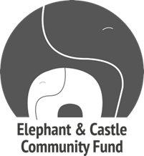

Elephant and Castle Community Fund
Round 11
Fund guidelines 2023/24

Fund guidelines

About the fund
We are delighted to announce that the Elephant and Castle Community Fund will continue this year. The fund was set up in 2012 with a donation from Lendlease to support the local Elephant & Castle community during the regeneration of the area. Since then, the fund has continued thanks to generous donations from Southwark Council, Lendlease and, since 2022, Get Living.
The fund aims to build on the strengths of local people, celebrate the rich cultural diversity of the area, and support the people who are most in need at this time of change. It is hoped that the fund will become a permanent feature of the area and that, over time, it will develop and grow, with the community taking ownership, both in decision-making and fundraising.

These guidelines outline the fund eligibility and criteria and tells you how to apply. The Elephant and Castle Community Fund is managed by The London Community Foundation (LCF) and is open to proposals for work taking place in the Elephant and Castle Opportunity Area.
The deadline for applications is 5pm on Tuesday 13th June 2023.

Fund area
Projects must be of benefit to people who live, work or study in the Elephant & Castle Opportunity Area (see map on page 8).

Grant size
Organisations can apply for grants of up to £10,000 to be spent within 12 months of the grant award date for projects that support residents of the Elephant and Castle Opportunity Area (see map on page 9).

One grant of up to £20,000 may be awarded to one organisation to deliver a project within 24 months of the grant award date. The grant will be released in two instalments: £10,000 in year 1 and £10,000 in year 2. This will go to a project which is able to demonstrate progression over the two years and clear outcomes. Organisations will be provided the opportunity to register interest for this multi-year grant when completing the application. In addition, the fund will offer capacity building sessions to all successful organisations.
Income threshold
There is no income threshold for groups applying to this fund, however, we are looking to support local community projects and priority will be given to locally based community and resident organisations. If your organisation has an income of over £1m per annum, please call and speak to us before you make an application. In a competitive situation, priority is likely to go to smaller organisations.

Closing date for applications
The deadline for completed applications, including all supporting documents is 5pm on Tuesday 13th June 2023. The funding period for delivery of services starts early September 2023.

Eligibility criteria - who can apply?
Please ensure you have read these guidance notes, especially this section, carefully to ensure your organisation is eligible for support.

Specific eligibility for this fund
- All posts (including staff members, sessional workers, part-time or full-time posts, freelance workers) funded by these grants must be paid at or above the London Living Wage (currently £11.95/hour). You can learn more about the Living Wage by clicking here. (http://www.livingwage.org.uk/what-living-wage).

LCF’s core eligibility criteria
- Eligible legal structures - there must be a signed governing document in place appropriate to the legal structure which includes an asset lock (or equivalent clause), and the purpose of all funded activities must be charitable (not for profit):
- The organisation must not have two years of net current liabilities within the two most recent completed financial years
- Charitable Incorporated Organisation (CIO)
- Company Limited by Guarantee (CLG) – may also be registered as a charity or a Community Interest Company Limited by Guarantee (CICLG)
- Trust
- Unincorporated Association
- Community Benefit Societies (CBS). Ideally, the CBS will also be registered as charitable with HMRC, however this is not essential.
- Governance
- You must have at least three unrelated members legally responsible for the governance of the organisation; trustees/directors/management committee as appropriate to your structure. Please note that this refers to the highest level of governance, a management committee that sits below a board of trustees (e.g. charities, CIOs) or directors (CLG or CICLG) does not count towards this.
- The organisation must have submitted required financial information to the Charity Commission/Companies House for the last two completed financial years.
- The organisation must not have two years of net current liabilities within the two most recent completed financial years.
- Bank account: a bank account in the same name as the organisation applying with a minimum of two unrelated signatories must be in place by the start of the grant.

- Safeguarding: you must have a safeguarding policy in place that has been reviewed in the last two years.

- Previous LCF funding: all conditions from any previous The London Community Foundation grants must have been met, and any monitoring that is past its due date must have been submitted on time at the point of application. This means that we cannot fund an organisation that has overdue monitoring, but we can fund organisations with future monitoring due on other grants with us.

- Registration: if the income for charitable purposes is more than £5,000 at the point of application, organisations must have submitted an application to register with the Charity Commission or the relevant regulator (e.g., Companies House, CIC regulator or Financial Conduct Authority). If the LCF grant will take the organisation over £5,000, please visit this website for guidance on setting up a charity, including information on legal structures.
Who and what are not eligible
- The following types of organisations are not eligible:
  - Companies limited by shares (including CIC limited by shares)
  - Statutory organisations, such as local authorities
  - NHS bodies
  - Co-operative Societies

- The grant funds cannot be used for:
  - Activities that promote religious or political views
  - Purely commercial ventures (for profit)
  - Spending that has already taken place (i.e. retrospective funding)
  - Individual sponsorship or redistribution of a grant to individuals or other organisations
  - Activities where people are excluded on the basis of religion, sexual orientation, sex or ethnicity (unless the issue is group-specific)
- There must be no personal benefit attached to the grant
- The organisation must not have two years of late submissions to the Charity Commission/Companies House within the last two completed financial years
- The organisation must not have two years of net current liabilities within the two most recent completed financial years
- Organisations where Trustees are paid are not eligible unless evidence of approval is provided from the Charity Commission and/or this arrangement is referenced in the governing document.
- Organisations with fewer than three unrelated members responsible for the governance of the organisation; trustees/directors/management committee, as appropriate.

What can we fund?
Please note that organisations which do not meet the criteria below, or which do not submit the required documentation at the time of application will not be considered for this fund.

Grant purpose
Applications must address at least one of the following themes:

- Further education, skill building, training and entrepreneurship
Helping residents to increase their educational attainment, develop skills, access training and gain employment. We are keen to support projects that create pathways to employment, volunteering, and work experience, and encourage socially enterprising activities which are of benefit to the community. We are also keen to see applications for digital training for residents who are currently digitally excluded.

- Arts and culture
Promoting engagement in arts and cultural activities, in particular, those that celebrate the diversity of the area and improve the local environment.

- Young people
Engaging and improving the lives of young people in the area, providing youth activities, and supporting young residents to reach their potential.

- Wellbeing
Promoting wellbeing, helping people to connect with others and addressing what are known as the Five Ways to Wellbeing. These are: Connect, Be Active, Take Notice, Keep Learning and Give – activities that individuals can do in their everyday lives to increase their wellbeing. Please visit https://www.mind.org.uk/workplace/mental-health-at-work/taking-care-of-yourself/five-ways-to-wellbeing/ for more information. Applications on food insecurity and obesity will also be considered under this theme.

- Environment
Increasing access to green spaces and improving the local environment within the Elephant and Castle Opportunity Area, with particular emphasis on projects where residents are involved in making the improvements themselves. We are also interested in proposals that respond to the climate emergency to achieve emission reduction.
The theme of the environment has been underrepresented in previous applications. We are therefore keen to hear from organisations looking to deliver work on environment issues and building partnerships to benefits the environment.
Examples of the types of environmental projects that might be funded include:
- Food growing or food waste prevention projects, reuse/recycling projects, greening and/or wildlife habitats
- Supporting the community in generating sustainable energy
- Education or training projects relating to the local environment including gardening skills and forest schools
- Skills development projects for local people relating to the climate response including carbon literacy, re-use/repair skills and energy advice
Fund criteria and priorities
Applications must meet the following criteria:
- The majority (at least 90%) of beneficiaries must live, work or study in the Elephant and Castle Opportunity Area (see map on page 9).
- Projects must meet a locally identified need. You will need to demonstrate that the project is wanted and needed by communities who will benefit, for example, through consultation or informal feedback.
- Applicants must commit to the Southwark Stands Together pledges - Southwark Council, and be able to demonstrate or commit to developing a diversity improvement strategy.
- Applicants must demonstrate how the proposed work meets a gap in provision and/or complements existing services.

Fund priority
- Applicants that are based within the Elephant and Castle Opportunity Area.
- Projects that work with the most disadvantaged members of the community, in particular, those who are not currently accessing services.
- Applications that actively involve the communities who will benefit from the grant in planning the project and making it happen.
- Projects that will have a clear plan to measure their longer-term impact on the Elephant and Castle Community.
- Projects that encourage community cohesion, partnership building and celebrate diversity.
- Projects that have a sustainability plan for continuation beyond this funding period.
- Projects that engage local people as volunteers (outside of any management committee members).

This fund supports “full cost recovery”, this means that you can apply for the direct costs involved in delivering your project and a proportionate share of your organisation’s overheads (the cost of rent/utilities/core administration staff, etc. for the whole organisation).

Budget breakdown
- In the budget breakdown, section 4, there are two cost boxes, one for the total amount of the project and one for requested amounts you are applying to us. The cost breakdown allows you to enter the details for the specific cost. These details should only refer to the elements of the proposal that are covered by your grant from us. Please give us a full breakdown of the project costs over 12 months.

*Note for volunteer costs – Only out-of-pocket expenses can be paid to volunteers, who should submit receipts and/or proof of payment such as bus/rail tickets for your records. Volunteers should not be paid a flat rate as they will be classed as employees of your organisation.

Monitoring of your work
We aim to keep reporting requirements to a minimum. However, LCF also needs to understand the impact of the fund and community need so that we can use this information to try to raise more funding, learn and improve our future funds. For further information and tips on monitoring your work, there are several useful websites, such as https://knowhownonprofit.org/organisation/impact and http://www.evaluation.org.uk/

How to apply
We aim to make the application process for this fund as quick and easy as possible. The online application form can be accessed by clicking on the ‘Apply now’ button on the webpage: https://londoncf.org.uk/grants/elephant-castle-community-fund
1. Please read the instructions carefully.
2. Tick to confirm you agree and have understood them.
3. Enter your e-mail address.
4. Click on the “Send e-mail and continue” box.
5. Once you have done this you will automatically be sent an e-mail with a link to your unique online application form. You should receive the e-mail within a couple of minutes (please check your junk mail folder).
You can save your application at any point and come back to it to complete it at any time before the closing date, by pressing the save button before closing your application.
Please make sure you have submitted all three of the required supporting documents:
- A copy of your signed governing document, i.e. Memorandum and Articles of Association or Constitution
- A copy of your most recent signed annual accounts or a current forecasted income and expenditure sheet for new organisations
- A copy of your safeguarding policy – this must have a date showing that it has been reviewed in the past two years

We regret we are unable to consider applications that are incomplete, submitted after the deadline or which do not have the relevant up-to-date supporting documents included, so please ensure you submit everything by the closing deadline of 5pm on Tuesday 13th June.

What happens next?
We may contact you to discuss your ideas by phone or email. You should hear the outcome of your application by August 2023. Therefore, your project should not start before September. If you are awarded a grant, you will have 12 or 24 months to spend it.

A panel of representatives from Lendlease, Southwark Council, Get Living and local residents will then meet to discuss and agree projects for funding. The panel decision is final and cannot be appealed.
Fund timeline and decision-making process

Please note we are unable to consider applications submitted after the deadline or which do not have the relevant, up-to-date supporting documents included.

Tuesday 9th May Applications open

Tuesday 13th June Application deadline @ 5pm

Mid-August Decisions released

Early September Earliest date projects can start for grantees

Some suggested top tips for applications:
- Draft responses before completing the online form and save them in a Word document.
- Make sure that every question has been answered in full (the form will prompt you).
- Ask somebody to read through the application before sending, preferably someone who knows nothing about the organisation. This is a great way to pick up on any mistakes or lack of information and rectify it before submitting.

Further information
Please contact applications@londoncf.org.uk or call us on 020 7582 5117 if you have any questions about the fund. You can also download resource packs on what to include in your governing document and safeguarding policy from The London Community Foundation's website at: https://londoncf.org.uk/apply/resources.

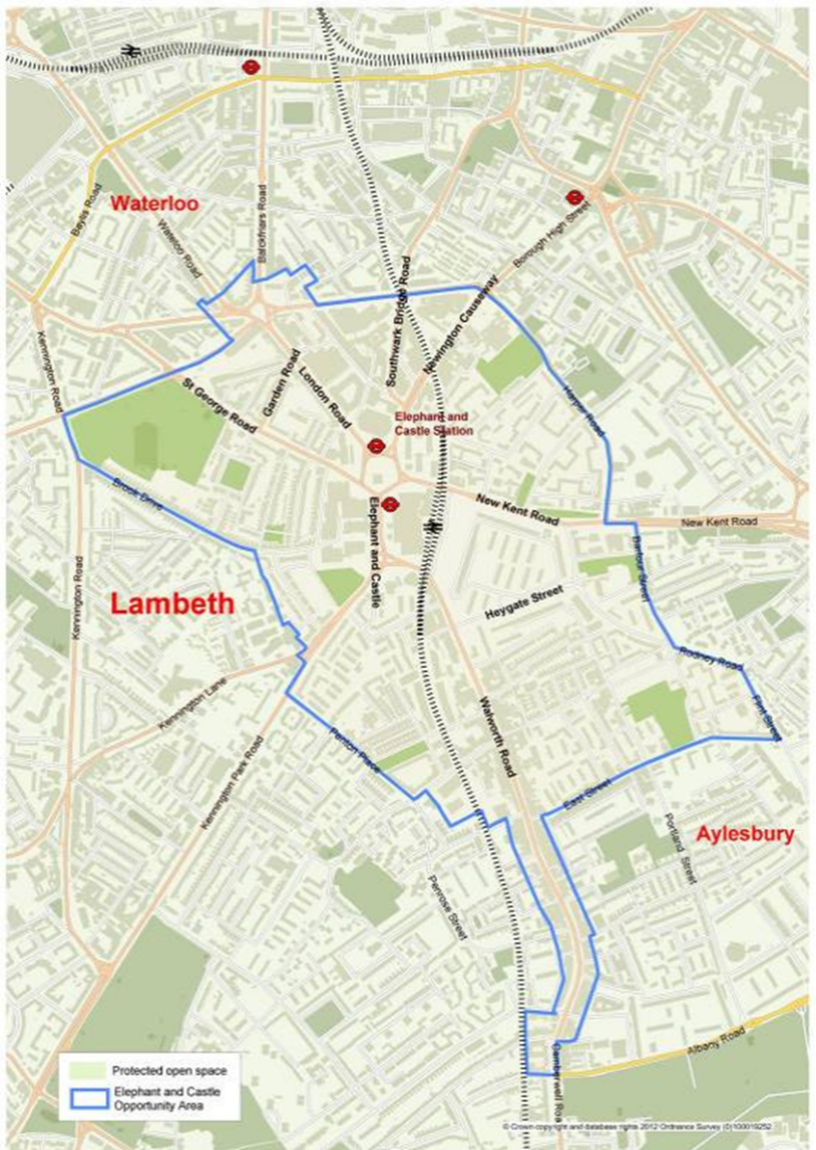
Elephant and Castle opportunity area

londoncf.org.uk
Registered Charity 1091263

